**Repast Monarch Model notes**

**10/23/15**

Changes after I sent model to Gabe

ZoneAgent.java – line 34, changed “Geography” to “Monarchs”

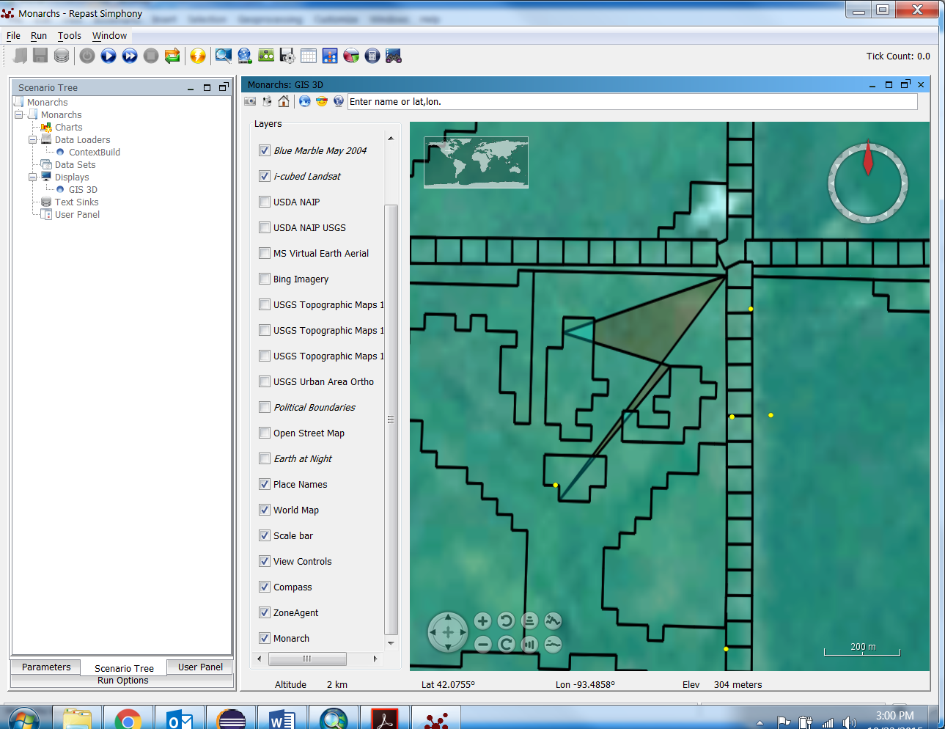 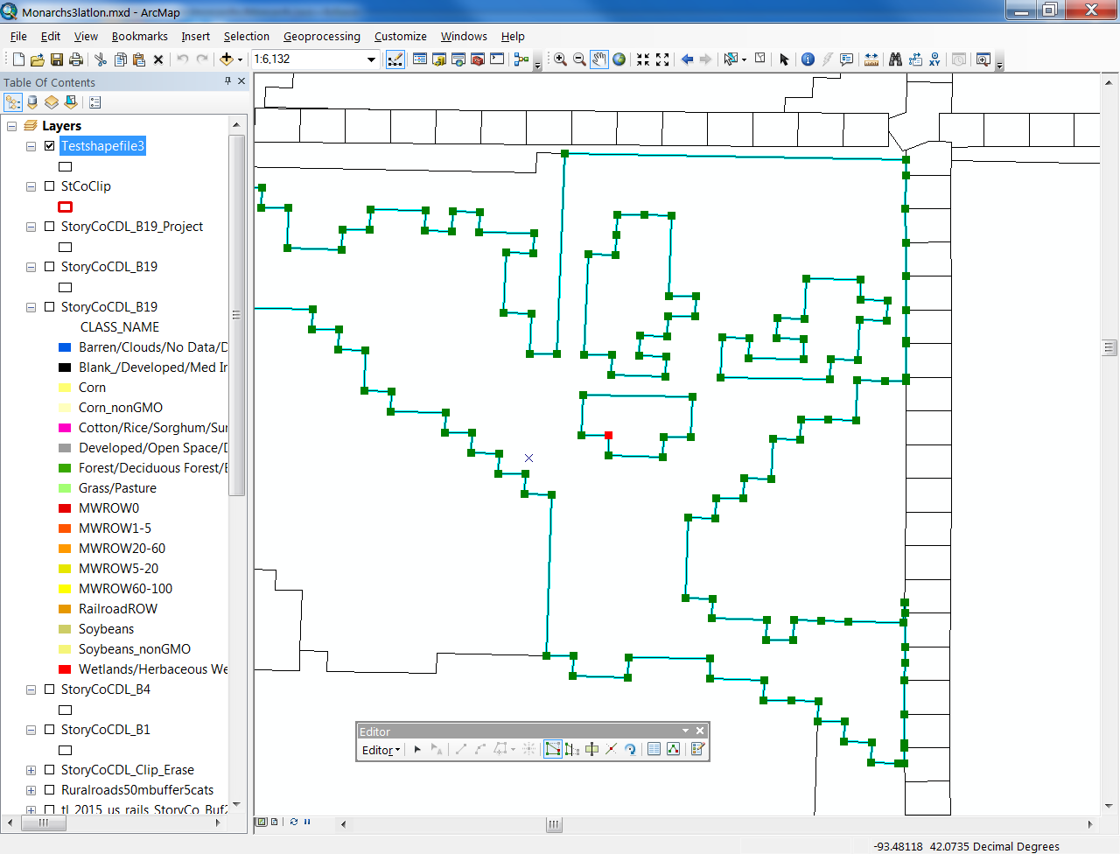

**11/4/2015**

Model is running butterflies in a correlated random walk. Torus situation is working, though I created the geography fac in ContextBuild and again in Monarch.java, not sure if that is right or if I can call it from ContextBuild. Random placement of butterflies seems to be slightly outside boundaries on east and north. I tried to run 100,000 butterflies in the small test area just to see if it could handle, but it couldn’t – after 25 mins I got out of memory errors. Will probably need to run about 100,000 in Story county. Never did resolve the above shapefile issue, but its not important in the large scheme of things.

To do next:

* Figure out how to query what shapefiles are within a certain distance and how far away they are. Then come up with some algorithm of how to choose which one to go to. I can change its mind and choose a different one each step, but it doesn’t stay in the current polygon if it has a choice. I think some sort of MW density by distance relationship should define the probability of choosing to go toward a polygon.
* Time steps for days and within days need to be added
* Egg situation needs to be set up
* A network to show the path of each butterfly needs to be added

Then on to simulations and sensitivity analyses etc.

**11/13/2015**

Got distance and egg-laying in model, but need to keep track of how many eggs each monarch has, so can see how many left at the end that they didn’t lay.

Also a technicality that they lay 4 eggs each time, even if they don’t have 4 eggs left.

Also need to set 4 eggs as var, so can change the number of eggs laid each time.

Gabe is working on movement choice

Next need to work on network of tracks.

**11/20/2015**

Seem to all be laying eggs on first tick.

Need ArrayList to keep track of eggs laid per day and how many not laid per day – or use Repast built in data collection.

Need to figure out how to get data out of Repast and why agent info doesn’t update to changes in code

**11/23/2015**

I think eggs are being counted correctly now. I made 5 output files for different data to collect. They go to the Model Output folder in the Modelling with Repast Simphony folder.

The most general result is **CumulativeEggs.txt**. This is the cumulative eggs laid across all zones. It’s shown for each tick, so the last one is the main result.

**ZoneEggs.txt** has the most numbers. It goes through each zone and each tick and for each zone gives the cumulative eggs laid there. So for the test shapefile there are 724 zones, so there are 7240 numbers, each representing the number of eggs per zone per tick and obviously the last 724 are the only important ones. There are no zone labels, which is what I need though.

**DailyEggstoLay.txt** is the number of eggs each monarch has at the end of a tick. So if there are 10 butterflies, the first 10 numbers are the number of eggs left for the 10 monarchs at the end of the first tick, then so on, for 100 numbers. So eggs laid is this number subtracted from possible eggs to lay.

**TimesLaidEggs.txt** is the number of times left that the monarch could have laid eggs in tick/day. It’s just the number of eggs to lay divided by 4. And if a monarch lays eggs it decreases by 1. It shows how many more times a monarch could have laid eggs if it had the chance.

**NumberofSteps.txt** is just the number of steps a monarch CAN take in a tick/day. And probably do, since they never run out of eggs in any simulations so far.

Combined some data sources, so now 3 output files with labels, tick, etc. Numbers are the same as above however. Note that timeslaideggs should be times left to lay eggs. New files are **EggsPerZone.txt**, **CumulativeEggs.txt**, and **Monarchdata.txt**.

Next:

* variable for number of steps taken for code check? Other code checks?
* When do I need @Override on a method??
* MOVEMENT DECISIONS

**Monday 12/7/15**

Model is running with movement decisions as of Friday. Need to add in egg-laying (only do it during random walk right now). Also need to get a better way to convert distanceOp lat/long units to meters.

Also thinking of adding in a random jump of 200-500 m north because they get stuck in places. Or they only look for MW to the north.

It’s also possible the model would be more realistic if the landscape was divided into 50m grid, which would allow for possible rare locations with milkweed in the corn field and allow them to escape roadways.

Talked with Bradbury. There are about 4 ways to model monarch movement that we can think of. First, and easiest is the ~300 m jump with random probability. Otherwise could add in preference values so probeggs and pref values are separate. Or could keep track of which polygon butterfly has been in and not let them go back. Or create 50 m grid to spread out probs and have some good spots in ag fields.

First gonna try the random jump one because it’s the easiest. Have to change code to keep track of meters rather than steps though.

Perception distance causes a buffer zone. For example, they never get within 100 m of a lousy field in some cases because always choose to not go there. But I thought if they chose current polygon they should random walk. So need to explore that more to see if that’s whats happening. Because buffers seem to be happening in some cases.

**12-8-15 Tuesday**

Might be worth it to put display in local UTM projection.

Doubled-checked that JTS.orthdromic distance is calculating what I want with appropriate accuracy. Calcs are in parameter excel spreadsheet. Seems accurate to well under a meter. So that’s not the problem.

The problem is that the code seems to be including some polygons beyond perception distance and the terminate distance in the DistanceOp. So trying to figure out why.

Tried DistanceOp without terminate distance. Without terminatedistance I never get distances above perception distance, weird… So for now going to use it without for now. It’s not noticeably slower.

I found an error in my corr rand walk. I always used the original random angle to base my change in angle off of.

I probably need to turn landscape into 50 m grid because when they have more choices at roads, they have higher chance of taking one of those choices, I think. I could weight probs by area, but they seem to be able to find small patches, so they might not be realistic either. Probably have to try different methods.

After talking with Gabriel (he programmed random jump into model), he thinks a 50 m grid is too ambitious and not necessary and may even give too many choices. The other option is adjusting pref values by area of polygon within 100 m. Gabriels other idea was to just get the type of habitat of each of the polygons and calc prob based on habitat type instead of individual pref values per polygon.

To do:

More intensive debugging

Organize code into better methods to make more readable

Sensitivity analyses – prepare for meeting with biologists – fix output methods

See if there is an area of polygon class

**12-11-15, Friday**

Had issues with int and double for egg counts so just changed everything to double. Redundant to count no of steps, should just do until eggs <= 0.

I really think I’m going to have to do something like decrease prob of laying eggs in a site they have already laid eggs in.

On RepastL they said there is a utility to see what is taking all the memory in Java program. It’s JVisualVM. Installed Eclipse Memory Analyzer plug-in, but can’t find it again and didn’t understand how to use it.

Changed heap size in eclipse.ini file to 1024 instead of 512. 2048 wouldn’t work.

Also added “-Xms256M -Xmx2048M” to default VM arguments in Eclipse prefs | Java | installed JRE’s | Edit. Realized need 64 bit Java and eclipse, currently have 32 bit.

Somethings wrong, when some eggs left to lay, don’t move as much as they should? No it’s because sometimes they take large steps. So I changed the output.

My Excel spreadsheet is based on steps taken, but steps are different lengths !!!!!!!!!!!!!!! Well still fine I think.

**12-14-15 Monday**

Got to wondering what points on polygon distanceOp is measuring. Not vertices hopefully. Wouldn’t make sense. But how close are points it is testing???

Using RStudio to calculate summary stats, etc.

**12-15-15 Tuesday**

Yesterday thought numsteps was calc’d wrong, but it wasn’t. Changed to cumSteps anyway.

Got some simple sensitivity analyses done. Stepped through polygon choice and its working right. I don’t think there is anywhere left any bugs could be.

Talked to Bradbury and he agreed I should add scaling by area and a memory to monarch agents before doing more extensive sensitivity analyses.

**12-17-15**

Got model running with area scaling and remembering past polygons it has been in. So I think it’s in really good shape for now. Several people have mentioned wind. Could account for wind with oval perception distance that extends far up wind and movements biased by wind direction. But save that for later!!! Time now to get some better data on what we have.

Talking with Royce we also had the idea that probably they shouldn’t stop flying when they run out of eggs.

Next need to step through model, esp the p’s, again to make sure its doing the right thing – see if the memory also needs to be scaled by area, for example if they have been in the same polygon for the last 10 steps. Then start running sensitivity analyses. Get ppt ready for team. Distribute model to team.

Change area scaling so small polygons are not 0.

Email Eric Tatara and John VanDyk

**12-18-15**

Watching print out from p’s for decision making and I think I need to leave out distance effect and not make area effect so drastic. Still haven’t figured out how to adjust memory for area.

I tried to change p so that is scales by area and probEggs, but after I did so it went back to concentrating in roads. So changed back to depending only on area. Could try again after getting memory to scale by area.

Leaving out distance effect, they don’t go into fields as often. Basically I penalized probEggs so much sometimes it was worth going into fields. Right now all decisions are made on probEggs. I could change it so that sometimes they don’t consider probEggs when moving.

Final model – left out distance and scaled memory using a logistic function so there is no memory effect for large polygons.

Tried to run 100 monarchs, can’t finish:

1-2:13pm

2-2:14pm

3-2:17pm

4-2:25pm ended sim

50 Monarchs:

0-2:39pm

1-2:39pm

2-2:40pm

3-2:40pm

4-2:41pm

5-2:41pm

6-2:47pm

7-2:56pm

8-3:14pm and stopped

25 Monarchs:

0-3:17pm

5-3:18pm

10-3:19:40pm

To do:

Step through code when it chooses the polygon to make sure its doing the right thing.

**January 4, 2016**

Batch run notes:

Runs through all combinations of parameters. Any machine that can connect with SSH and use the JVM can run batches. Output file sink can’t have folder, just file name, to make sure it gets recorded somewhere.

Output from GUI defaults to C:\Users\tgrant\Documents\Repast\Monarchs

Output from batch runner goes to C:\Users\tgrant\Documents\Repast\Monarchs\output

Ran two scenarios, 50 and 55 monarchs – started 8:47. Took 11 mins without the GUI!

9:05 am started 100 monarchs – 1024M VM – 21 mins.

Next test run 100 monarchs, 2048M VM, and fixed cumegg.txt – 20 mins. Used about 5 Gb RAM.

Next test run 100 monarchs, 4096M VM – RAM peaks at 5.9 Gb, doesn’t seem to need more than that. – 23 min

Next test run 100 monarchs, 6144 VM – 10:35 AM – RAM went to 6.3 Gb – 23 mins

Conclusions – more RAM is better, but doesn’t seem to affect time much.

Running 100 monarchs over and over: tried space separated values for no of agents with 2 instances of localhost and 8082M memory: processor was going flat out until the RAM all got used up! So it is memory limited. RAM is right around 8 Gb. 29 mins.

Could turn off recording locations for display during batch runs.

Conclusions – max RAM and multiple instances on local comp is better.

*Notes for removing display:*

Block commented out 2 sections toward the end – recording 2nd coord and display network method – this makes it so the network is not saved. Tested in GUI and no network shown.

Ran 100 Monarchs in 2 instances again, 8082M VM, but without network display: only 6 mins. 200 Monarchs in 6 mins is not too bad, or much better anyway.

Maybe try to get Memory Analyzer to work again.

Ran 4 Instances of 100 Monarchs each on local comp, 8082M VM. Space separated list for No. of Agents. All 4 processors were running flat out until memory ran out. 14 mins for 400 monarchs. Now we getting somewhere.

Next need to test with larger shapefile or run sensitivity analysis in current shapefile.

**January 5, 2016**

CLEANING CODE

**January 7, 2016**

Found a possible bug. Area that comes out of shapefile is in lat/longs, and sometimes is 0, which might not work very well in the logistic equation for memory.

Yes, logistic equation was based on zone agent area x 1 million. Doh.

Don’t forget in ArcMap to change properties of field to show like 10 decimal places to the very small numbers. They are importing into Repast correctly though either way.

Ok, found correct parameters, but was easier to just fix it by multiplying area by 1 million. All calcs are in the spreadsheet for parameters.

Running model with new shapefile with probEggs at 50 percent of original and only drop 2 eggs.

***Finally at 10% of original, Monarchs rarely lay all their eggs.***

Running models on speedy2, did directionality sensitivity analysis. Things are running well with 20 instances. Need to try larger landscapes soon. Used about 2 Gb when I was looking at it with John.

**January 8, 2016**

In run6, run 15 only got to tick 6, I don’t know why. Everything else was fine though.

It doesn’t make sense to have the perception distance less than the step length.

Running it in the GUI, run6 runs just like a correlated random walk all the time.

Looking at GUI, when perception distance is 400, they tend to clump up a lot more, like I’ve been trying to avoid.

Other parameterizations, like 10 m step lengths, also tend toward clumping as well.

I need another way to measure movement, like distance between initial and last location every day, or a heat map of daily locations. Home range analysis or kernel analysis of size of area used.

Looking into R package “move”.

Three possible response variables: number of eggs laid per monarch, distribution of eggs on landscape, utilization distribution of individual monarchs.

I want real field data of tracks. Google “tracking tags insects butterflies bees”.

**January 11, 2016, Monday**

Guiding principles for model:

1. Don’t lay all their eggs
2. Utilization distribution is similar to natural UD

**January 12, 2016, Tuesday**

Steve likes the sensitivity analyses but wants more of the combos to show patterns are occurring away from just combos based on baseline.

Run 20 is to test if relationship between perception distance and step length holds at different values for both.

**January 13, 2016, Wednesday**

Tried to summarize simulation data by zone, but ran into some problems. Need to accumulate eggs per zone across the 20 instances, but need to output Zone ID to make sure adding together same polygons. So I can run simulations again or:

1. Assume they are always output in same order, which is probably true
2. Summarize data keeping 20 instances separate

OK, reset data collection and sinks in RS to just collect cumulative eggs at tick 10, significantly decreasing data output. Also added zone ID and area of zone. Area is in lat/long units, so not too useful. Could convert in arcmap before? RS? R? arcmap after? If necessary.

Got script done for mean cumulative eggs per zone, but need mean proportion of eggs per zone.

**January 14, 2016, Thursday**

Analysis of cumulative eggs per zone for simulations I have already run:

I have 20 instances, each with 724 polygons. So I have 14480 rows, each with a number for eggs accumulated in that zone. I took the mean and SD of eggs for all instances. If I combined instances the mean would obviously be about or maybe exactly x20. Then for proportion of eggs in each zone, I took the total eggs over all 20 instances and divided each of the 14480 zones by that. This is a mess, but the patterns should be right. If means and proportions are higher, it means more clumping and less spread out movement. And proportion will control for cases where more total eggs are being dropped, like in step length simulations. I multiplied proportions by 100,000 just for easier reading.

In the future, I will combine all 20 instances, but because I don’t have individual ID for each zone, I was not certain they stayed in the same order, though I’m pretty sure they did.

**January 15, 2016, Friday**

New simulation of step length at 18 m doesn’t fit pattern. Next week double check it, because output file was different.

Run 6, instance 15, is missing a few 4 ticks for some reason.

**January 22, 2016, Friday**

John Pleasants noticed some strange behavior at edges and I realized model was remembering angle for correlated random walk when it did correlated random walk if it chose current polygon.

So wrote new method for correlated random walk when it chooses current polygon which initializes to a random angle instead of using angle from previous correlated random walk.

Is there a better way to do this? Choose angle away from edge??

**January 25, 2016, Monday**

Tried 2 other algorithms for what happens when monarchs hit edge. Simplest solution was to use a random angle for corrRW if they chose current polygon. This resulted in a lot of random floating around the edges. Next solution was to initialize to a new random angle if they were starting a new random walk, i.e., if they weren’t in a random walk the previous step, the angle was set to random value again. This resulted in better behavior, but still a lot of clumping.

So now I think original thing was best, because it’s like the Monarch trying to get out – they keep going in the direction they were going. Finally they get out.

To change back to 2nd solution, search for incorr variable and uncomment them.

An intermediate solution would be to have them periodically change angle, or change angle after they have tried for a while.

**January 26, 2016, Tuesday**

Finished getting it coded so that directionality changes with probEggs.

Wrote ICE abstract

Worked on getting area of polygons to calculate egg density. I used a shapefile that was projected in NAD83. Might have to calculate area within Repast.

Or put ID number in GIS, pull into Repast, and then can crosswalk those.

**January 27, 2016, Wednesday**

Importing FID from shapefile into Repast so I can get area of polygons correctly associated with cumulative eggs of polygons to get egg density. Repast wouldn’t get the FID using feature.getattribute. feature.getID(); didn’t seem to work either. So just exported GIS attr tables to Excel and used those numbers – checking that all numbers match so I’m sure I have right area for polygon.

Have to run baseline over to get individually ID’d polygons.

**February 1, 2016, Monday**

Rerunning baseline with new output files that have individual ID for polygons and also directionality now varies by milkweed density.

**February 2, 2016, Tuesday**

Arrived 5 a.m. Changed ID for polygon in RS to double instead of string because I couldn’t turn it back into a number in R so I could loop through it.

Ok finally got egg densities. Now what to do with it.

Would be nice if I could get it back in ArcMap and put a color scale on the densities to see where the high densities are.

What effects could there be? – area, distance to other habitat patches, etc

There is an effect of area – smaller areas have higher densities for other habitats besides road polygons which are all the same size of course.

**February 4, 2016, Thursday**

Fragstats moving window analysis sounds promising.

Neighborhood-oriented indices.

Spatial configuration – aggregation.

It seems like to me a measure of all the area within a certain distance of different habitat types would be the index that would be very informative, i.e., within 100m, there is ∑areai*probEggsi=index for habitat types i. I just made this up though, not sure if there is a name for it, though it seems obvious.

Other observations: Roadside milkweed next to non-gmo fields doesn’t have high density of MW. It seems like small groups of small polygons have the highest density.

I need to do sensitivity analysis on these to see how density changes with different parameter values.

Fragstats takes rasters, so would have to convert shapefiles back to raster or use rasters used to create shapefiles, but not sure everything is in there. So probably better to get other sensitivity analysis done before doing landscape analysis.

Cushman et al. 2008 was probably the most useful paper I read. Aggregation metrics seem most useful.

Last night thinking about higher densities on roads. I think its possible more choices/polygons create higher densities? Could easily test with a completely fake landscape with different size and configuration of polygons. Then the big question is whether it’s an artifact of the model or whether it also happens in the wild.

Question: what is best configuration? Small groups of small patches have higher density, and therefore more parasites, i.e., a density dependence effect? Bigger patches have lower density and probably fewer parasites. Though it could be an artifact of the model, because what is assumed to be homogenous in the model could actually be patchy in RL.

Tomorrow finalize new shapefile by seeing if I need objectID field.

**February 5, 2016, Friday**

Steve was asking about differences in simulations, so I ran baseline again and compared to first baseline run (run 24 and 25). Densities differed more than I expected, but difference over all sites was very close to the same.

Got new shapefile, but forgot to get dimensions for randomly placing monarchs into shapefile. Got these from inside RS.

SW corner: 42.0025, -93.6534

SE corner: 42.0029, -93.5484

NE corner: 42.0829, -93.5489

NW corner: 42.0825, -93.6540

Slightly inside:

SW corner: 42.0026, -93.6533

SE corner: 42.0030, -93.5485

NE corner: 42.0828, -93.5490

NW corner: 42.0824, -93.6539

There a few places in the code where lat lon coords have to be changed: the static xmin, xmax, ymin, and ymax in Monarch.java, the init coords for visualizing the network, and initializing the locations of the monarchs.

Also loaded with errors. Repaired it in ArcMap.

Emailed repast list again to see if they can help.

**February 8, 2016, Monday**

Looking at FRAGSTATS again, aggregation indices would be most valuable. Nearest neighbor might turn out to be most useful. **Proximity index** sounds like what I was thinking about last week.

Moving window analysis would likely be impossible – too much computer time needed.

After talking with Steve, sensitivity analysis on utilization distribution would probably be good.

Also remember to compare real data from Pleasants, etc., to model results.

**February 9, 2016, Tuesday**

Looking at new shapefile, it may be that the display is the only problem, the shapefiles are there and working.

Still getting an occasional error though, need to debug it.

It’s a 0 divided by 0 error, which gives NaN. It seems to happen if monarch comes to boundary of two polygons with probEggs of 0.

I think I fixed the problem.

Monarchs still get hung up on 30m cul-de-sacs or fingers, maybe should smooth out some by hand. Sometimes might be good for them to head away from edge, esp if probEggs = 0 for thing heading away from.

**February 10, 2016, Wednesday**

Working on run times for the proposal. Created shapefile for St Co. It’s an issue getting the area to stay as m^2. Can make new field and copy m^2 into it, because usually when you change projection to just geographic WGS 1984, units change to lat/lon units in Shape_Area (other times it doesn’t change… haven’t figured out difference yet).

Monarch got stuck on a 30m outcrop again. But all 37148 polygons are output to the output text file, even though it’s too many to show in the GUI table button thing.

**February 11, 2016, Thursday**

Created a shapefile for NW Iowa (some notes in GIS notes file as well as in this file). New problem is that I can’t just use x,y coords of a rectangle to keep monarchs within shapefile, will have to do some sort of query to see if they are in a shapefile, then moving it will also be annoying.

Can put in temporary x,y rectangle just for testing. Trying to think of a way to move them to correct place.

Should I reclass CDL as 50 m? Better to use 30 m step length.

Ran some tests and the model is seeing the polygons that don’t show up in the GUI.

I need to test some of the counties on the river to see if ricochet always works or if they can find their way out and wander off into the wilderness.

**February 12, 2016, Friday**

Created new shapefiles for NW IA and western Lyon Co. Both are just the CDL with smaller polygons (<9000 m^2) eliminated. NW IA is for testing large areas, but it has that weird Mo Riv western border, so going to test new algorithms for butterflies to ricochet off Mo Riv in W Lyon Co. If I need to test stuff right away I can use a clipped square out of NW IA shapefile (sf).

**February 17, 2016, Wednesday**

Tried to load NW IA clip, but RS GUI ran out of memory.

Added –Xmx8082M to default args but didn’t help.

Ran on speedy2 but didn’t seem to work – no output. Error loading features. Error was because I didn’t put probEggs into shapefile.

I created a new .calc file for putting in probEggs because categories in this shapefile are different because I haven’t combined or modified the CLASS_NAMEs.

Model works now on speedy2. Ran 100 monarchs first and worked fine, then ran 6,000, which took the same amount of time as when I ran 6,000 in Story County.

Now to fix display problem ANL was fixing for me.

The new .class file Eric Tartara sent me broke Repast so I replied back and gave him the error. Will try to call today or tomorrow.

So next I guess I need to program ricochet and storage of monarch coordinates. I could program Eric Tartara’s test to iterate through polygons to see if all are being recognized. Ricochet or coords first though.

Ran 12,000 monarchs in NW IA. Then ran 24,000 monarchs. John VanDyk set up website so I can see how much memory is being used on speedy2. He says if memory runs out, I’ll have to run fewer cores and allocate more memory to each, which would take longer, so going to run some tests on that at the end of the day (night) so they can run while I’m sleeping.

**February 18, 2016, Thursday**

Remember to do a big run at the end of the day.

Working on recording all tracks and analyzing that.

Going to try to work with fully Story Co shapefile. It’s slow though. Agent table in RS GUI shows 37,148 zone agents, which is the same as the attribute table in ArcMap. But not all are displaying in the RS GUI. Ran multipart to single part. 37,165 polygons.

Worked on outputting x,y coords for utilization distr analysis, but need to talk to Dave. I have an ArrayList of x,y coords I need to output, and I don’t want to create an individual method for each coordinate… has to be a way to just output the whole arraylist. Sent email to repast-L.

Ok, I got it coded that if the monarch finds itself not in a polygon, it goes back 100m (or 2xsteplength) at a heading of 180 different from how it got there.

Some things to think about:

* Disable code transporting it around torus?
* Change corr rand walk heading by 180?

Now need to test it in West Lyon Co along with a bunch of println’s.

Had an idea about randomly placing monarchs – if first location they are in is not a polygon, try another spot – add in when it becomes important.

Got an error with West Lyon Co shapefile: found non-noded intersection between LINESTRING

Going to try repair geometry and mp to sp.

The issue is not with the shapefile, the issue is that the monarch gets stuck out of the shapefile and moves until it hits 180 deg longitude. So something is wrong with the code but can’t figure it out yet.

**February 19, 2016, Friday**

Last night realized I didn’t put ‘== false’ in if statement condition. Duh. That wasn’t the only problem though, found that I had to use 0.0 as the condition, not just 0.

Now getting a rare error in the correlated random walk for when it chooses the current polygon. The error is that the angle is above 360 or less than 0.

Problem appears to be that some probEggs in shapefile were 999. So fixed that by using correct .calc file.

But brings up question of whether range of probEggs in corrrandwalk2 has to be exact. I ran calcs in Excel and it will not give an error, directionality will just not reach the minimum.

STILL getting the error though.

Ran with printlns and found error happened when probEggs = 999, which I thought I got rid of. Maybe doesn’t save attribute table until exit from ArcMap. So closed and opened ArcMap and RS. Well, problem was that shapefile I modified wasn’t the one in the /data folder for the model. So got right shapefile in there now, should work fine now, forever and ever.

So ran model for a while in West Lyon Co, and there is a very rare case when it can screw up. I should add a counter for how many times the monarch is not in a polygon in a row, and move it back into a random place in the shapefile if it gets above 10 or so.

Ok, added counter, but it counts how many times bounces in 1 tick. Can’t figure out how to get to just increment bouncecounter when it happens in a row.

So bounce seems to work fine enough, so moving on to coords.

Tried a method like Eric Tartara suggested, or something like it, and it only output one coordinate per tick.

So trying method recommended by Nick Collier. Got it to work and got R package move to work.

Set up one last run on speedy2 with NW IA Clip using new model. Output never came back though, probably because coord output files were too big. Well, took 7 hours to copy 12 Gb coords.txt file. Figure below is from this big run.

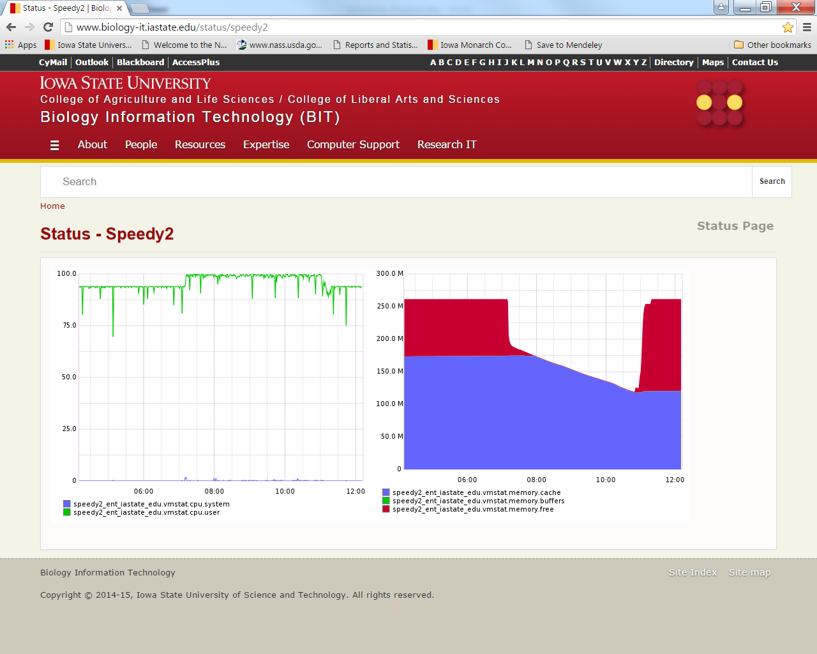

**February 22, 2016, Monday**

Working on sensitivity analyses today. Working on doing UD analysis for Story Co. Checking how well story co runs and if polygons are valid. Its running awfully slow, I’m going to code the model to easily turn coord saving off and on.

It looks like bouncing causes some error in the number of steps and distance moved – steps are counted but not distance moved.

Using Eric Tartara’s line of code to look for invalid geometry, I got these for Story Co:

Invalid geometry: StoryCoB19_sp.158

Invalid geometry: StoryCoB19_sp.207

Invalid geometry: StoryCoB19_sp.411

Invalid geometry: StoryCoB19_sp.579

Invalid geometry: StoryCoB19_sp.693

Invalid geometry: StoryCoB19_sp.842

Invalid geometry: StoryCoB19_sp.889

Invalid geometry: StoryCoB19_sp.938

Invalid geometry: StoryCoB19_sp.1449

Invalid geometry: StoryCoB19_sp.1543

Invalid geometry: StoryCoB19_sp.1776

Invalid geometry: StoryCoB19_sp.2108

Invalid geometry: StoryCoB19_sp.2216

Invalid geometry: StoryCoB19_sp.2344

Invalid geometry: StoryCoB19_sp.2409

Invalid geometry: StoryCoB19_sp.2572

Invalid geometry: StoryCoB19_sp.2732

Invalid geometry: StoryCoB19_sp.2774

Invalid geometry: StoryCoB19_sp.3040

Invalid geometry: StoryCoB19_sp.3054

Invalid geometry: StoryCoB19_sp.3104

Invalid geometry: StoryCoB19_sp.3302

Invalid geometry: StoryCoB19_sp.3619

Invalid geometry: StoryCoB19_sp.3647

Invalid geometry: StoryCoB19_sp.3665

Invalid geometry: StoryCoB19_sp.3744

Invalid geometry: StoryCoB19_sp.3762

Invalid geometry: StoryCoB19_sp.3804

Invalid geometry: StoryCoB19_sp.3830

Invalid geometry: StoryCoB19_sp.3881

Invalid geometry: StoryCoB19_sp.4008

Invalid geometry: StoryCoB19_sp.4021

Invalid geometry: StoryCoB19_sp.4180

Invalid geometry: StoryCoB19_sp.4288

Invalid geometry: StoryCoB19_sp.4324

Invalid geometry: StoryCoB19_sp.4525

Invalid geometry: StoryCoB19_sp.4570

Invalid geometry: StoryCoB19_sp.4573

Invalid geometry: StoryCoB19_sp.4835

Invalid geometry: StoryCoB19_sp.5108

Invalid geometry: StoryCoB19_sp.5113

Invalid geometry: StoryCoB19_sp.5273

Invalid geometry: StoryCoB19_sp.5362

Invalid geometry: StoryCoB19_sp.5524

Invalid geometry: StoryCoB19_sp.5704

Invalid geometry: StoryCoB19_sp.5751

Invalid geometry: StoryCoB19_sp.5827

Invalid geometry: StoryCoB19_sp.6243

Invalid geometry: StoryCoB19_sp.6496

Invalid geometry: StoryCoB19_sp.6579

Invalid geometry: StoryCoB19_sp.6586

Invalid geometry: StoryCoB19_sp.6752

Invalid geometry: StoryCoB19_sp.6874

Invalid geometry: StoryCoB19_sp.6882

Invalid geometry: StoryCoB19_sp.6942

Invalid geometry: StoryCoB19_sp.6970

Invalid geometry: StoryCoB19_sp.7020

Invalid geometry: StoryCoB19_sp.7231

Invalid geometry: StoryCoB19_sp.37014

Need to call him today. 59 bad polygons out of 37,165 polygons or 0.16%. I want to figure out which ones they are, so going to try to get RS to load the FID from ArcMap. I think I tried it before and it didn’t work though. Yeah, FID won’t load as double or string, apparently. Trying ORIG_FID. Didn’t work. Tried OBJECT_ID, which finally work when cast as a long, BUT NOT AS A DOUBLE or INT. Now can’t get Tatara’s line of code to return the OBJECT_ID.

ID used in Tatara’s getfeatureID() seems to be FID-1. But those polygons seem to be fine, at least I can double-click on them in RS GUI and the info comes up. FID 37,014 displays in RS GUI and comes up on click. FID 7231 doesn’t display but comes up on click. Called Tatara and left a message.

I’m going to try to run some big sims and see if I can see the problem areas, for example if home ranges slide around them or no eggs get laid.

Should add code to turn off network when running on speedy2. Though may not make much of a difference when saving coordinates anyway.

Running 1,000 monarch baseline model in Story Co. to start sensitivity analysis. Will look at density and UD of these results.

To calc density in Denresults object in RStudio, takes how long to loop over the 37,165 polygons? 2:10 AM – 2:18 AM. Less than 8 mins.

I spot checked StPolyArea and dens to see if polygon ID and area matched up and they did, but I should subtract them from each other to see if always 0. Should always be 0 if they are in the same order.

To look for polygons that aren’t recognized in RS, because they imported incorrectly, I’ll have to use a simulation with many more polygons and look for polygons that had 0 eggs laid. There are still a lot with 0 with this simulation that has only 1,000 monarchs.

When I joined DensityResults33.csv with StoryCoB19_sp, I subtracted the areas from each and they are all the same within rounding error, so my R code is correct that the indices match and also it may mean that valid geometry in model is not giving the right answer.

So got density data in R, just thinking how to best represent data. The histograms are skewed and when I take logs they get more clumped because data has natural clumps at 2/2500, 4/2500, 8/2500, etc.

Better just to use all 6,000 or more butterflies for density.

So switch to UD for a while.

I got a list of 1000 elements, each is a monarch, need to convert it to data frame but there are different numbers of locations in each row. It’s usually 1550, but sometimes more if it bounced.

Tomorrow get density from 10,000 monarch run that is running now and figure out how to get monarch locs into a dataframe from the list. The movestack for package move takes lists, so maybe don’t need dataframe.

**February 23-24, Tuesday**

Running 2 monarchs in the GUI to see what the error was I was getting yesterday.

It has something do with writing to the file sink. So I created code to just write some meaningless numbers to the output file if savecoords was set to false. Turned out to be a bigger pain than I thought though because I had to change the name to a different variable, name2, which was only written once instead of over and over. Finally got it to work so 9999 only is written to coords output file. It still writes a line for each monarch, but not the long string of coords and hab types.

While testing model, a monarch went around the torus instead of bouncing off…

Got it working, so ran 10,000 monarchs in Story co for egg density analysis.

In the meantime, working on doing UD analysis for multiple monarchs from run 33.

MoveStack isn’t going to work apparently, but I can just loop through a list.

Testing different values of raster and location.error to see if they affect process time.

Location.error seems to have no effect, or slight decrease speed, so I’ll use a small number. Well, 0.001 seems to take least time, so I’ll use that.

At 30 raster size, single tracks don’t make it into 95% UD. At 20 they start to and at 10 they are very visible. Raster 30 is probably fine and only takes 25s.

Have to make sure to use same size raster because area depends on raster size. For the test UD, area is 519, 1163, 4659, for 30, 20, 10 raster size, respectively.

Will take 8.3 hrs to run 1000 monarchs if each one takes 30s. Trying 10 at time first. Took 15 mins to run 10. At that rate will take 25 hours so better run ½ or ¼ at a time.

Would be nice to figure out the actual area of the UD, but depends on the raster and projection and all that.

Stopped when I filled Denresults with run 35 – next need to do stats by habitat type and map it.

Going to leave R calculating UD’s now.

**February 24-25 (Wednesday)**

Started approx. 9:05 AM. 142 were done by 11:05 AM and 226 were done by 12:40 AM.

250 UD’s finished by 4 pm. Two of these warning messages: “Outer probability: 0.0151844036787957 The used extent is too small. Choose an extent which includes more of the probabilities.”

Monarch workgroup meeting…

* + Leslie Ries – interested in numbers, how to detect trends – collaboration
  + Kelsey needs comments by noon
  + Monarch numbers from Mexico in press conference Friday

There are some very large outlier areas, shown in the histogram. Plotted all 250 plots, weird ones are: 232 (22305), 188 (69010), 171 (52264), 128 (9612), 71 (6859), 66 (6914), 190 (3939), 119 (2410). Look at 58, 45, 26 too. 26 must have got stuck, so I removed it too.

Plots 100 at a time.

Problem areas are on edges. Would be better if bounced?

Run 250 or 500 more at the end of the day.

Egg density – got mapped in ArcMap. There are only a few polygons with 0 eggs. I want to check if these are not recognized by the model. I need to get probEggs into the density results data frame to exclude everything with 0 probEggs. Also to do regression on size of plot vs. density.

Saved new file with probEggs to DensityResults_b.csv. A multiple linear regression of eggdensity ~ probeggs + polyarea was significant for polyarea at p = 0.0486 (probeggs was highly significant, of course). But I need to do a log transform or other nonlinear regression. Also ran exp/log1p regression, which was very, very significant.

It appears that higher density per smaller area is an emergent property of search behavior. It’s difficult to explain this intuitively. They just find smaller ones more often, they keep re-finding it?? In any case, it may not be a biological instinct in the monarch to look for small patches, it may just be an emergent property of search behavior. How can we leverage this? What is optimal arrangement?

The other big question is what are the characteristics of sites that get higher densities of eggs – FRAGSTATS should help with this. Though I really don’t look forward to using it.

Now what stats to use for sensitivity analysis???????

I can’t think of anything better to use than mean and SD of egg density per habitat type, but I’m not sure that captures what changes might happen. What changes could happen though? I guess I should use ln(egg density). Except lots of zeros, so that doesn’t work well.

In the meantime running 10,000 monarchs in St Co with 30m step length.

Got all of mean, SD, and median egg density per each habitat type.

Worked on time budget, but need to loop through 1000 lists of habtypes.

My R workspace is getting very large (340 Mb). Maybe I should split the analyses into different workspaces.

**February 26, 2016 (February 25 workday) – Thurs/Fri**

All UD’s ran, with several of that same error which probably comes from the big outliers.

Removing a bunch of outliers again. Check 330, 284, 271, 253, 442, 424, 405, 367 (ok), 533, 510, 475, 459, 457, 455, 644, 638, 637, 634, 615, 613, 608, 595, 588, 746, 660, and 653.

Remove 653 (area 6984), 588 (area 16196), 595 (30798), 613 (16173), 615 (21202), 634 (31345), 638 (24018), 644 (47339), 455 (19419), 457 (75544), 459 (32041), 510 (4478), 405 (4918), 442 (28052), 253 (12501), 284 (4439),

Remove 660 (area 98), 746 (38), 608(7), 637(10), 475 (181), 533 (48), 424 (48), 271 (26), 330 (12), they got stuck at least for a while.

595 is really weird, not sure what happened there. Also 608. I think 595 got stuck outside and bounced 50 times so then it randomly placed back inside. Only time I saw it happen. If that’s what happened.

In summary, for 750 UDs so far, had to remove 9+1 because they got stuck and 16+7 because they were on the edge and got crappy dbbmm results.

After removing outliers, data looks great. Mean area is 872 with SD 288.

They get stuck along the edge fairly often. I wonder if there is an issue there. See, for example, 649, 631, 670, and 580. Those maps look weird because of the scale, so hard to tell. Are they being drawn and held at the edge because of an edge effect?

I think its best if they bounce off the edge instead of doing the torus for these home range analyses.

Also look at greatest distance between points. I thought move calculated that but it doesn’t. It does give the extent, i.e., the min and max x,y coords that form the bounding box of all the points. The area of this could be used. It would be highly correlated with UD anyway.

To do:

Program model so they always bounce off edge.

Finish calculating time budget

I finished time budget code which was a nightmare because of nested lists.

Tomorrow I’ll look at bouncing again.

**February 27, 2016 (Feb 26 work day)**

UDs 751-1000 finished.

I had an idea overnight. Increase probEggs on all polygons, run 10,000 monarchs, and see if any polygons don’t get eggs. I should do that.

Checking UD’s for bad ones. Check 850, 815, 789, 778, 757, 753, 906, 902, 866, 851, 999, and 994.

Remove 850 (14694), 789 (18127), 778 (16122), 757 (371,458), 902 (11841), 866 (8271), 999 (15291), 917 (3714) – too big.

Remove 815 (15), 753 (9), 906 (12), 851 (19), 994 (13) – got stuck.

An easy fix for bounce issue would be to make x,y min-max larger, so that it has to bounce instead?

So, what the code does currently is:

1. Check for distance to polygons within perception distance (it has already moved).
2. If there is no distance that is 0, meaning it is not in a polygon, it bounced back 2 steps and other movement occurs in that step.
3. But even if there is a distance that is 0, meaning it is in a polygon, it will get transported if outside x,y boundaries. It should get transported before the final move however.

So I don’t think torus movement should trump bounce movement, except when x,y boundaries are slightly inside shapefile boundaries, which is exactly what they are.

So I just made x,y boundaries 100-200m outside of shapefile. Bounce should work now. So I’m running a 10,000 monarch sim in St Co with 10m step length. Started 7/8 AM, should be done 6.7 hrs, or about 2 pm in Utah.

Densities are much higher for 30m simulation because more eggs are laid. So going to look at proportion of eggs laid per habitat type.

Workspace is 600Mb and getting unwieldy, so saved it as Mon1.Rdata and will start a new workspace next time.

Working on graphs of first sensitivity analyses of eggs laid per day. Getting more professional graphs in R. What was original sensitivity analysis on? One things was percent of eggs laid per day/tick, but wasn’t there another?

I should probably run simulations again with 10,000 monarchs in St Co. Right now they are 1,000 monarchs in the test shapefile. I can at least get graph set up going.

Got some graphing going in RStudio, remember to put one in the report next week.

R Graphics cookbook is in Documents\Monarch Butterflies\Modelling with Repast Simphony\Model Output

At end of day run 1,000 UDs from run 36.

Never mind, savecoords was not active for run 36, so have to run 1,000 on Monday and use those.

Other thing to do Monday is run a simulation where probEggs is high for all polygons to see if any are not being recognized by the model and see if small polygons still have higher densities of eggs.

So on Monday, first run 1,000 monarchs for UD analysis, that will go fast. Then run simulation with 10,000 monarch in St Co and test shapefile where probEggs all = 0.1.

**February 29, 2016, Monday**

The run I tried on speedy2 over the weekend didn’t work. Not sure what happened. Need to test model to make sure it’s working right. Then might have to run far fewer monarchs.

Today run 1,000 for UD and 10,000 for next sim whatever that is.

Testing model in RS GUI and it seems to bounce fine off edges. So ran 1,000 monarchs with 30m step length and savecoords on. Worked fine. 100 monarchs with 10m step and savecoords on worked. Now running 1,000 monarchs with 10m step and savecoords OFF. Will probably have to run a few thousand at a time and concatenate them.

Go 50 UDs calculated. Check 26,31,19. All seem fine. Distr is flatter so far.

Saved workspace as Mon2.Rdata.

Probably will have to do 50m step length over again with bounce now.

Working on pub graphs for an hour until lunch.

Running 50 more UDs over lunch.

When current RS run is done, gonna run test shapefile with all probeggs = 0.1.

1,000 monarchs with step length 10 m finished running. Got some errors:

WARN [SwingWorker-pool-2-thread-1] 13:34:46,981 repast.simphony.batch.ssh.OutputFinder - No model output found matching glob:{**\\,}CumEggsPerZone*.batch_param_map.txt in C:\Users\tgrant\AppData\Local\Temp\simphony_model_1456764653958\instance_1

WARN [SwingWorker-pool-2-thread-1] 13:34:46,981 repast.simphony.batch.ssh.OutputFinder - No model output found matching glob:{**\\,}Monarchs*.batch_param_map.txt in C:\Users\tgrant\AppData\Local\Temp\simphony_model_1456764653958\instance_1

WARN [SwingWorker-pool-2-thread-1] 13:34:46,981 repast.simphony.batch.ssh.OutputFinder - No model output found matching glob:{**\\,}CumEggs*.batch_param_map.txt in C:\Users\tgrant\AppData\Local\Temp\simphony_model_1456764653958\instance_1

WARN [SwingWorker-pool-2-thread-1] 13:34:46,981 repast.simphony.batch.ssh.OutputFinder - No model output found matching glob:{**\\,}Coords*.batch_param_map.txt in C:\Users\tgrant\AppData\Local\Temp\simphony_model_1456764653958\instance_1

WARN [SwingWorker-pool-2-thread-1] 13:34:47,028 repast.simphony.batch.ssh.OutputFinder - No model output found matching glob:{**\\,}CumEggsPerZone*.batch_param_map.txt in C:\Users\tgrant\AppData\Local\Temp\simphony_model_1456764653958\instance_2

WARN [SwingWorker-pool-2-thread-1] 13:34:47,028 repast.simphony.batch.ssh.OutputFinder - No model output found matching glob:{**\\,}Monarchs*.batch_param_map.txt in C:\Users\tgrant\AppData\Local\Temp\simphony_model_1456764653958\instance_2

WARN [SwingWorker-pool-2-thread-1] 13:34:47,028 repast.simphony.batch.ssh.OutputFinder - No model output found matching glob:{**\\,}CumEggs*.batch_param_map.txt in C:\Users\tgrant\AppData\Local\Temp\simphony_model_1456764653958\instance_2

WARN [SwingWorker-pool-2-thread-1] 13:34:47,028 repast.simphony.batch.ssh.OutputFinder - No model output found matching glob:{**\\,}Coords*.batch_param_map.txt in C:\Users\tgrant\AppData\Local\Temp\simphony_model_1456764653958\instance_2

Speedy2 is down now for maint.

Speedy2 back up, running probeggs=0.1 with 1,000 mons and 50m step length.

Finished run, mapped density to ArcMap. Lots of ROW polygons don’t have eggs, but if they do the density is high BECAUSE THE POLYGON IS SMALL. Need a larger sample size – 10,000 monarchs.

Still the good news is that is appears that no polygons are not being accounted for in the model.

Running 10,000 mons with 30m step length and all probEggs = 0.1 to see how that looks.

**March 1, 2016, Tuesday**

dBBMM’s still running this morning until 9:45. Ran 10,000 monarchs in Story County with 40m step length. Started fiddling with the manuscript and citations in the meantime.

First sort through 900 dBBMM’s. Check 131, 138, 124,

Min was 927 (area 6). It’s weird I can’t tell why it got stuck.

Talked to Steve on the phone – staying until week of Mar 21.

Steve interested in this emergent property thing. His questions are: What does UD look like? Are they still hanging around edges? Mess with choice algorithm – see if can make them not hang around edges. How many monarchs lay eggs in a particular polygon?

Running all the step length simulations 30, 40, 50. Have to run 10,000 with coords then 1,000 with savecoords on.

When work over, run UDs for one of these sims and run big sim of 20,000 with all probEggs=0.1.

**March 2, 2016, Wednesday**

UDs for 50m ran faster (12 hr) than UDs for 30m. 20,000 mons in allprobegg=0.1 finished.

For 50m UDs, large outliers look fine. Several small outliers look stuck: 212,251,867,208,549,452,833 so I removed them, didn’t change much.

After combining run 42 and run 49 for 30,000 monarchs, only 17 polygons with no eggs. The polygonID’s (FID is polygonID - 1) are 7396, 7644, 8502, 9794, 10027, 13647, 16218, 16684, 17326, 17329, 19795, 20172, 25384, 27590, 27870, 28116.

For egg density per habitat type, going graph all first then maybe take some representative ones for pub graphs.

First doing run 48, 30m step length.

Proportion is not changing much, not sure if its informative.

Run UDs for run46, 40m step length.

**March 3, 2016, Thursday**

Almost done running step length sensitivity analyses. Just need more of the 10m scenario, which I have to run 1,000 at a time. So running another 10m 1,000 monarchs.

During conf call this morning with Thogmartin and Ryan Drum, thinking of how I could speed up sensitivity analyses. Most important would be to find a fast UD estimator. Also could just run 5,000 or 1,000 monarchs. Makes me a bit nervous because St Co so heterogeneous, could look at the 1,000 increments of 10m simulations and see how they change.

Ok, looking at UDs estimated from last night – run 46, 40m step length. Some clearly got stuck so removed them. Removed 11 monarchs cuz got stuck.

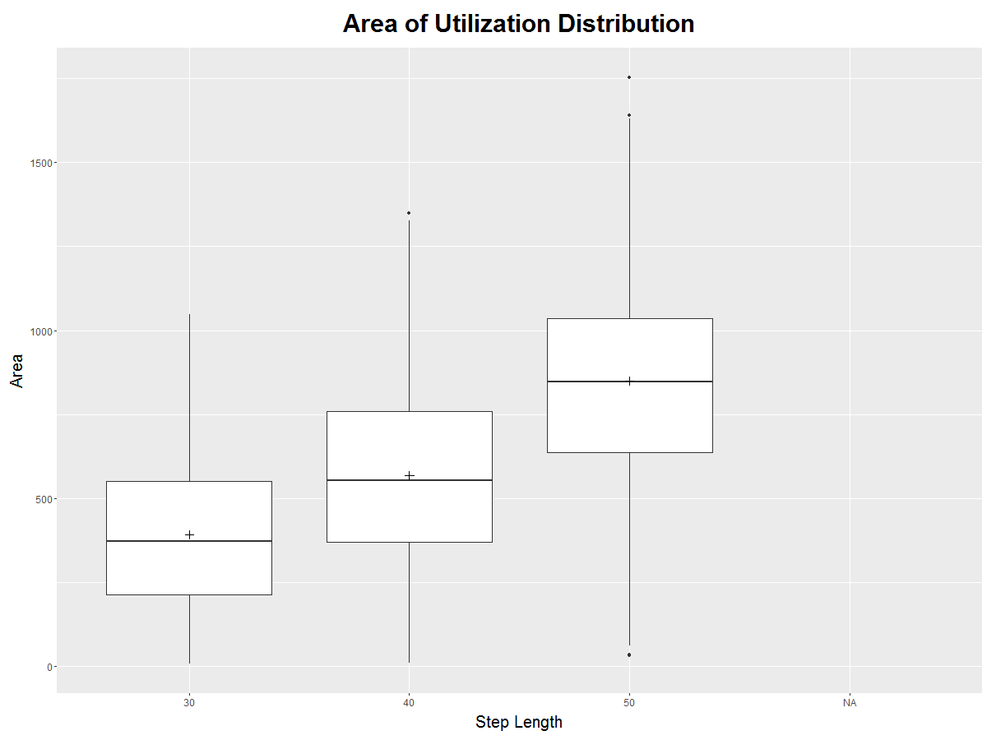

Need to run UDs for 20m step length next.

Looking at median egg density per habitat type, in addition to proportion of eggs per habitat type, to see if anything interesting happening there.

Now comparing the five 1,000 monarch 10m runs to see how different they are.

Started run 57 and started calcing UDs for step length 20.

**March 4, 2016, Friday**

RStudio is only done with 543 UDs this morning. The smaller the step size, the longer it takes to run. So I guess I’ll be working on the manuscript and other things today. I looked into stopping it to see if it would keep the ones already run, but I think everything is lost if you stop execution.

Emailed John VanDyck about how to get output from a run I did on speedy2 last night in which the batch runner somehow lost connection to speedy2. Need to install a ssh client, but can’t until RStudio done.

Reading Boleti 2015 thesis about home range analysis. It appears that map units of aeqd may be meters. But she also says that the time factor may affect UD estimation, so I should test a few with different time intervals and see how they do. Boleti doesn’t explain either why map units are in meters, but she uses raster=100 and says the units are meters. She does show how to export the contours to a shapefile, so I can do that and check area and also make some maps.

**March 7, 2016, Monday**

500 UDs finished over the weekend, took 39 hours. Occurred to me over the weekend that, if map units are meters and raster size is 30m, then 10m steps are shorter than raster size – what effect does this have on results?

First going to output some shapefiles to see what they look like and then email move people.

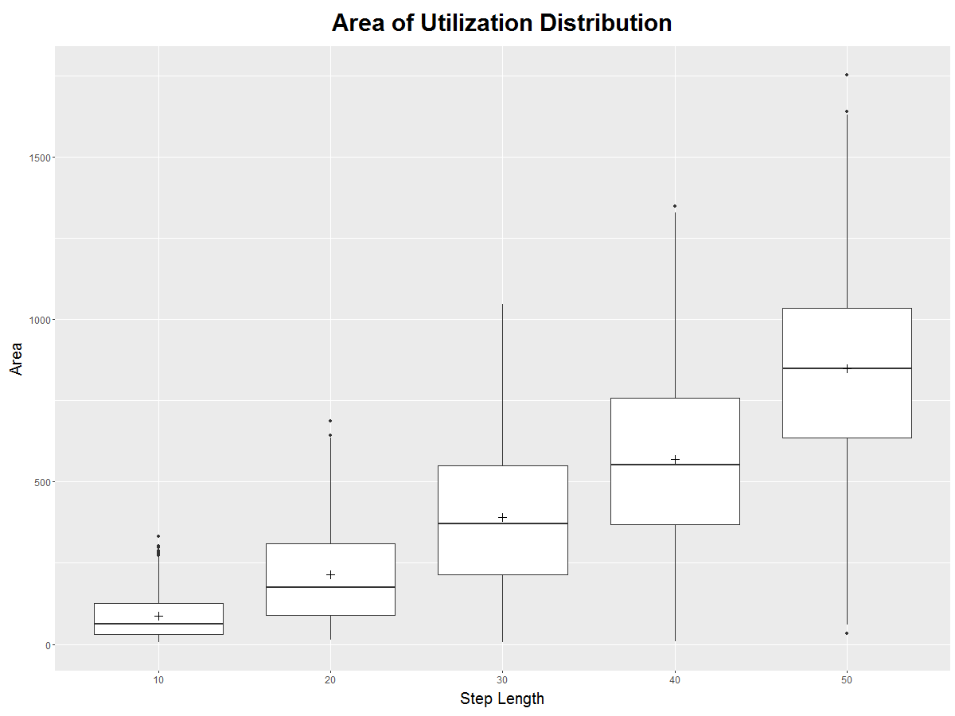

Got all 5 datasets into a graph (above). Only 500 reps for 10m though.

Outputting shapefiles – output shapefile is a polyline not a polygon, but in meters it matches dimensions of plot in R – i.e., it seems clear that units in R plots are meters.

I’ve never used window or margin values for dBBMM.

Also I can try BBMM from adehabitat package.

Graphing egg density for 10m sims (only 5,000 mons, not 10,000). Will probably be less because only half the monarchs. Doubled the egg density, but pattern still doesn’t follow other simulations.

Box plots of any?

**Mar 8, 2016, Tuesday**

Conf call with Steve. UDs still running. Run 63 finished overnight, started run 64.

John VanDyk says can run R on speedy2.

Worked on abstract for North Central Branch ESA.

Joined ESA, registered for ICE. Have to get reimbursed when I get back.

Dates for hotel: Sun, Sept 25 – Sat, Oct 1.

North Central Branch ESA: June 5-8, Sun-Wed – reserved a room.

**March 9, 2016, Wednesday**

Emailed EntSoc for reimbursement of registration. Emailed NremIT to get PuTTY installed.

PuTTY is installed.

Looked more at documentation for projections. Still can’t find anywhere it says meters, lol.

Got into speedy2. Would have to run R as command line in Linux, so going to try BBMM.

Testing BBMM with adehabitat package. Test different time intervals.

**March 10, 2016, Thursday**

500 UDs for run60 ran in 9 hours. I’m going to just do 500 for awhile.

Area of UD is not changing with changes in remembered. Bothers me a good deal. Need to test effect of other parameters on estimation of UD. But seriously, that can’t be the problem. It has to be a real effect. But why is it happening. Try at 50m step length to see what happens. It appeared to be a very real effect when I watched tracks.

Sent an email to Steve and an email to Hazel, Myron, and Steve with abstract.

I’m just going to run 500 UDs for a while.

Working on egg density graphs for remembered.

**March 11, 2016, Friday**

Everything is in weekly report.

On Monday, work on getting speedy2 R to work and test raster size of dbbmm a little more?

**March 14, 2016, Monday**

Adding perception distance 200 UDs – run 61 – to graph.

Worked on ms while I waited for john vandyk to update packages on speedy2. He never replied though, so maybe on vacation this week (it’s spring break)

Started simulation run 75 – perception=50, step=10.

Running UDs for 400 m perception distance, run 64.

**March 15, 2016, Tuesday**

UDs for 400m perception finished:

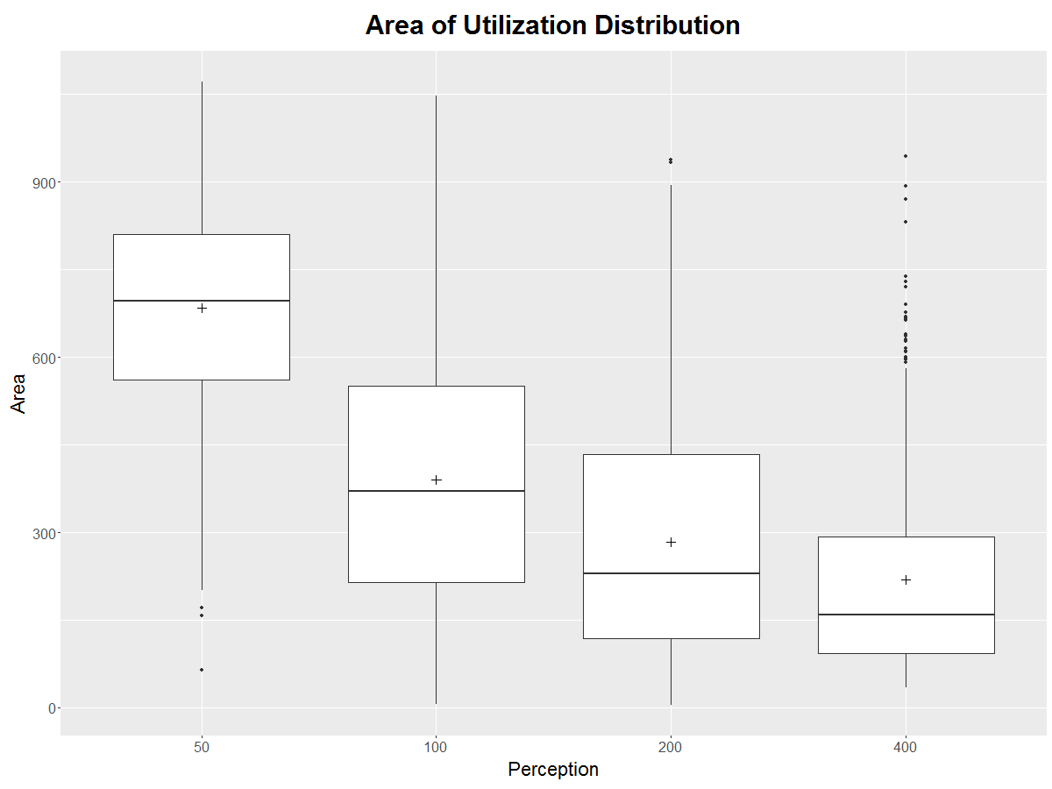

Running some simulations for perception=50, step=10.

Now doing eggs per zone for perception distance.

So have graphs for UDs and EZ for three parameters going away from the baseline: step length, perception, and remembered. I need graphs for combos of these, like step and remembered, and step and perception. I also need graphs for directionality.

Feb 19 was day I found directionality problem.

Looked at it again today in prep for directionality simulations.

Previous to now, code looked like this for corrandwalk2 and corrandwalk, respectively:

**double** probEggsRange = 0.075;

**double** localdir = (-(maxdir-mindir)/probEggsRange)*probEggs + 0.75;

**double** localdir = (-(maxdir-mindir)/.1)*probEggs + 0.75;

So I didn’t even have them the same lol.

In first case, since range of probEgg is 0-0.85, directionality dropped to 0.4666 instead of 0.5 for probEggs=0.085, so not much difference really. I have the equations programmed in Excel.

In the second case, directionality dropped to 0.53 instead of 0.5 for probEggs=0.085, so not much trouble either.

I don’t remember why I didn’t fix this better before, looks like I was frustrated with other problems and didn’t want to touch it.

I moved probEggsRange to a global/class variable and put it by maxdir and mindir so I’ll remember to change it if I need to.

Changed both methods to look like this:

**double** localdir = (-(maxdir-mindir)/probEggsRange)*probEggs + maxdir;

Tested it on 2 monarchs in RS GUI.

The sims I ran already with directionality 0.8-0.9 should just run again.

Next thing to look at is if remembered has different effects at step length 50. So started UDs for run 70 – step=50, rem=40. Started simulation where dir ranges 0.8-0.9.

**March 16, 2016, Wednesday**

UDs for run 70 took 12 hrs. Run 79 finished on speedy2.

Need to remove some UDs from run 70 and make a graph.

I can supposedly run R on speedy2 now, so I’ll give that a try.

Still get error, but it may not be a fatal error.

Here is UD from speedy2 – dbbms64[[1]]

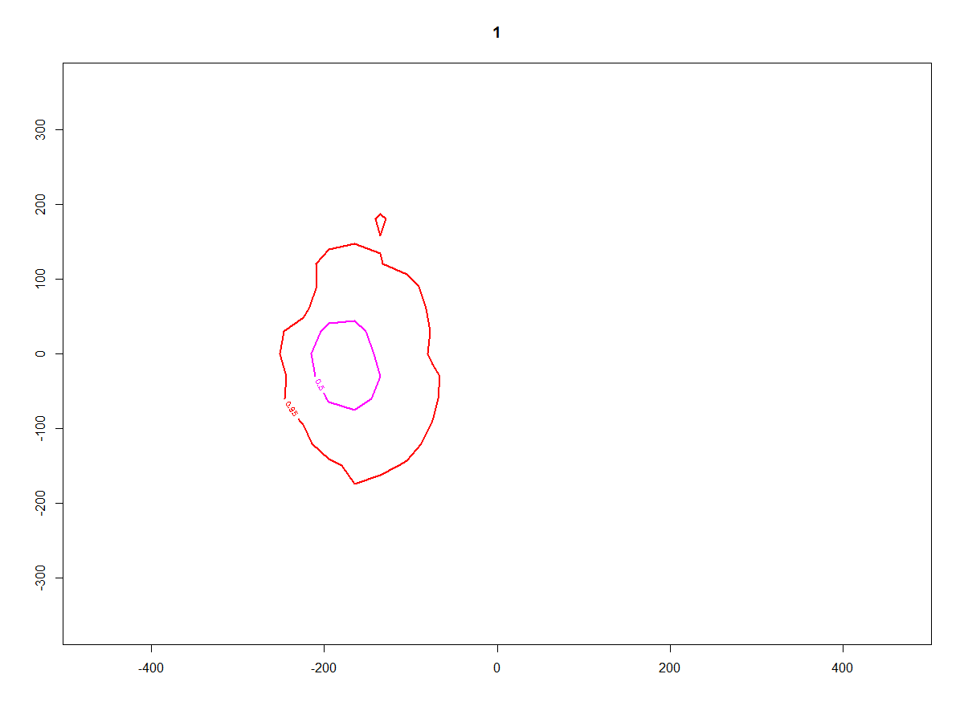

Here is UD from my PC/laptop:

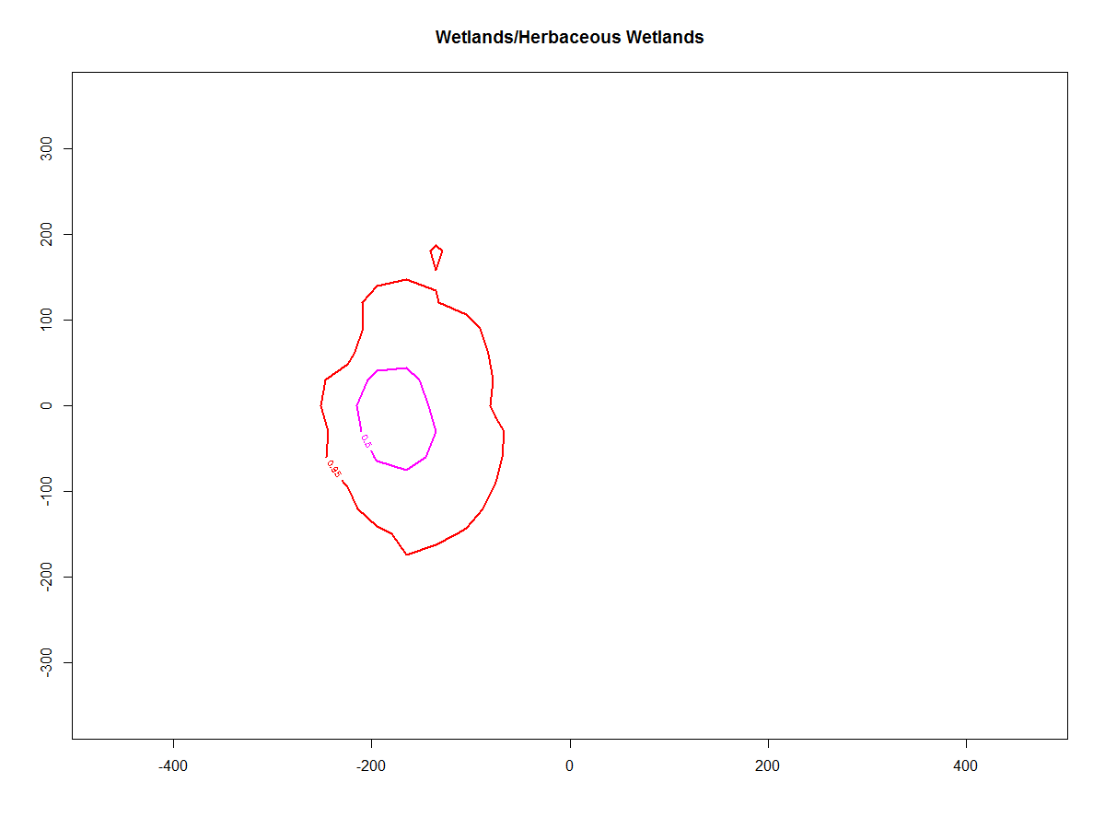

They look exactly the same.

I’m going to try to run 1000 UDs on speedy2 and see what happens. I’m doing run 45 – step=50, rem=10 (baseline for 50m).

Started run 45 UDs on speedy2.

Removed bad UDs from run 70 and got graph going:

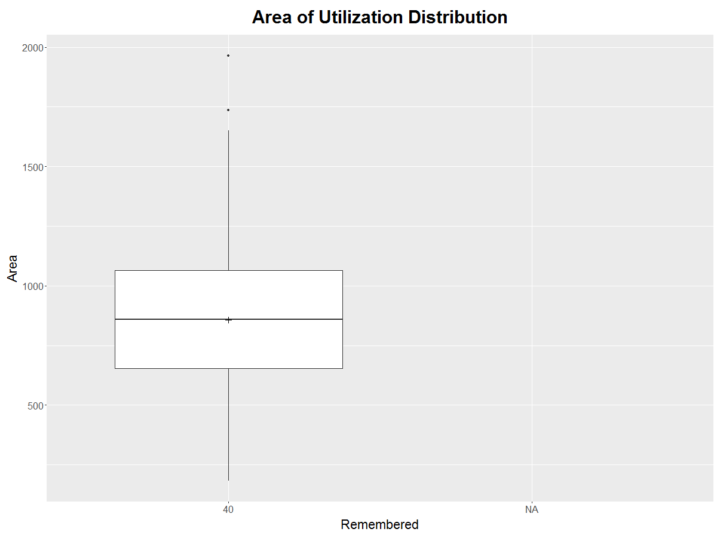

**March 17, 2016, Thursday**

I saved dbbmms45 from speedy2 to an .RData file and downloaded it from speedy2. Then I changed the name of the .RData file to dbbmms45sp2. But the object loaded was still called dbbmms45. So I opened it in another workspace.

Mean and SD of the UDs from both were exactly the same, so that error must be nothing.

March 18-21 – drove back to Iowa

**March 22, 2016, Tuesday**

Back in Iowa, time to run some serious UD calcs and simulations.

I added to the spreadsheet “Sim Runs” which ones had UDs calculated. I need to write down for each parameter what needs to be done though.

Starting R UD calcs on speedy2 for Run71 and Run 75, next need to do directionality.

Started run 71 at 7AM. Started run 75 at 7:30 AM.

Starting UDs for run 80, 81, 84.

Started run 80 at 10:15 AM. Started run 81 at 10:23 AM. Started run 84 at 10:33 AM.

Now going to add a section below to compile results for each parameter and see what else is needed.

**March 23, 2016, Wednesday**

Four of 5 UD runs finished on speedy2. Need to download each from speedy2 and make graphs.

Then need to figure out what other simulations to do with LHS or whatever.

There’s about 108 possible parameter combinations.

**March 24, 2016, Thursday**

I think I figured the LHS sampling. Writing R code to convert the lhs package numbers to parameter combinations to run.

I’m looking at 4 possible values for each parameter (LHS requires they all be the same number of possibilities). So there are 4*4*4*4=256 possible parameter combos.

I’m going to start with 20 parameter combos to run and go from there. I’m going to make sure at least some of the ones I already did are included.

Table of LHS values for R, i.e., simulations already complete:

|  |  |  |  |  |
| --- | --- | --- | --- | --- |
|  | **Step Length** | **Remembered** | **Perception** | **Directionality** |
| 1 | 0.125 (10m) | 0.375 (10) | 0.125 (50m) | 0.625 (0.5-0.75) |
| 2 | 0.125 (10m) | 0.375 (10) | 0.375 (100m) | 0.625 (0.5-0.75) |
| 3 | 0.375 (20m) | 0.375 (10) | 0.375 (100m) | 0.625 (0.5-0.75) |
| 4 | 0.625 (30m) | 0.125 (2) | 0.375 (100m) | 0.625 (0.5-0.75) |
| 5 | 0.625 (30m) | 0.375 (10) | 0.125 (50m) | 0.625 (0.5-0.75) |
| 6 | 0.625 (30m) | 0.375 (10) | 0.375 (100m) | 0.625 (0.5-0.75) |
| 7 | 0.625 (30m) | 0.375 (10) | 0.625 (200m) | 0.625 (0.5-0.75) |
| 8 | 0.625 (30m) | 0.375 (10) | 0.875 (400m) | 0.625 (0.5-0.75) |
| 9 | 0.625 (30m) | 0.625 (40) | 0.375 (100m) | 0.625 (0.5-0.75) |
| 10 | 0.875 (50m) | 0.125 (2) | 0.375 (100m) | 0.625 (0.5-0.75) |
| 11 | 0.875 (50m) | 0.375 (10) | 0.375 (100m) | 0.625 (0.5-0.75) |
| 12 | 0.875 (50m) | 0.625 (40) | 0.375 (100m) | 0.625 (0.5-0.75) |
| 13 | 0.625 (30m) | 0.375 (10) | 0.375 (100m) | 0.875 (0.8-0.9) |
| 14 | 0.625 (30m) | 0.375 (10) | 0.375 (100m) | 0.375 (0.1-0.9) |
| 15 | 0.625 (30m) | 0.375 (10) | 0.375 (100m) | 0.125 (0.1-0.2) |

Augmenting the simulations already done doesn’t work, it’s not strictly right, so I’ll have to get a sample that has a bunch of the sims I’ve done already.

Still trying to decide what parameter combinations to run and how many. I guess I can start with 5 or so and go from there.

Did Run 85, which had remembered set to 100. Ran fast.

I ran 3 monarchs in RS GUI with remembered = 500 and barely affects UD for some of them. Check if it’s working tomorrow.

I got a random LHS of 5 sims that has 1 I have done already. I saved it as a csv.

Friday:

Register for Cleveland

Check remembered code

Start LHS sims…?

**March 25, 2016, Friday**

Run 75 UDs finally finished on speedy2. Downloaded area75.RData. Graphed it. Perception 50 increased UD size over perception 100, as in other step lengths.

Remembered in model is not working. Tried most of the day to fix it.

Monday: Reservation for Monarch Keystone meeting

**March 28, 2016, Monday**

Found mistake in code. Shouldn’t use .asList.contains on primitives. Maybe it wasn’t a primitive before. Apparently it wasn’t because I’m almost certain it was working before.

Then discovered that the area I have been using is in meters, whereas it was lat/long units before. This number is pulled right out of the shapefile, it’s not calculated, so I have to be careful what area is in the shapefile.

It seems to be fixed. I could do more to test different parameters of the logistic equation.

Run 86 and 87 are a repeat of the Baseline to see if it’s the same or different. Started 87 at 1:29PM.

Got 10 combos from LHS in R that have 2 combos I already ran. Changed remembered 2 to remembered 0 to use sims already done.

1. Check to try to figure out when I might have changed code.
2. Start PRCC and regression for LHS combo results. -Split R code
3. Start LHS combos if everything ok

**March 29, 2016, Tuesday**

UDs for run 86 finished.

Sent email to Steve about model fix and the errors I found. Run 86 was very different from run 38 and they should be the same if run 38 remembered code worked right.

Started new runs for LHS combos, using old runs as remembered=0.

Tomorrow

1. Check if mean eggs laid runs will work with current runs
2. Local sensitivity analysis for remembered
3. Start writeup for local sensitivity analysis and results. Start methods for global sensitivity analysis.

**March 31, 2016, Thursday**

Had to kill Run 90 this morning, did thing where it makes way too many threads. So run only 2,000-3,000 at a time. Has 10m step length.

Looked at Debinski papers yesterday.

Did run 91 and started run 92. R is running UDs for run 89, has been for a few days. Started running UDs for run 91.

Did some more stuff.

Tomorrow

Get mean eggs laid for prcc analysis

Get plane tickets to orlando

**April 1, 2016, Friday**

Speedy2 rebooted overnight for quarterly reboot and I lost 3 R runs.

So restarting runs 89, 91, and 93.

Run 95 is set to go, which is LHS combo 5.

For mean eggs laid by step length, use same runs as for UD by step length: egg density runs corresponding to 38/48, 45, 46, 56, and 52

Working on graph of boxplots of egg density and excluding outliers. Line 753 in R code.

If (joke) then (laugh)

**April 4, 2016, Monday**

All runs finished on speedy2 over weekend. getVolumeUD wasn’t working for reason though. So saved dbbmms and tried again.

Run 89, 91, and 93 are corrupt or something. They show up as huge files (200-500 Mb) but show up in R as all NULL list elements.

For some weird reason, these 3 runs are each missing the first 148 dbbmms. So, good enough, sample size = 852.

Found out that I had the loop from 149:1000 still in text file - !!!!!!! argh

Running runs 97-98 and calcing UDs for run95.

1. Abstract for meeting next week
2. Then do mean eggs laid
3. Then local sensitivity analysis in ms

**April 5, 2016, Tuesday**

Run 98 finished on speedy2 and UDs for run95 finished.

Did runs 99 and 100 on speedy2.

Started UDs for run97 and run 99.

Abstract for ICE, mean eggs laid, local sensitivity, factors for Teresa

**April 6, 2016, Wednesday**

Run99 UDs finished, run97 UDs still running. Run 102 finished.

Run103 has rem=0, which threw an error, so need to fix that. Fixed it and HOPEFULLY NO UNKNOWN ERRORS.

For area99, I gave up throwing out bad UDs, because there are so few.

**April 7, 2016, Thursday**

Accidentally saved over dbbmms71.RData, the object is dbbmms97.

Steve wants to know what a buffer on ag of 150 ft or 75 ft would do to possible conservation areas.

Story County:

Using 50m road buffers I already had, there is 75,605,680 m2 = 7,561 ha of roadsides and 107,632,485 m2 = 10,763 ha of grass/pasture with no buffers. Ag fields comprised 1,114,946,919 m2 = 111,495 ha.

125ft = 38.1m, 75ft = 22.86

I made 38.1m buffer on ag fields and then erased that and calculated area again in StoryCoCDL_B19-125ft_Erase1 (First Erase failed cuz stuff was selected). New ROW area is 11,103,041 m2 – 1,110 ha and new GP area is 63,047,431 m2 = 6,305 ha.

Friday

* 75ft buffer – but that might not work with my 50m road buffers
* PPT for next week
* Continue global sensitivity analysis
  + Mean eggs laid
  + Run the last sims
  + Regression
* Local sensitivity analysis for remembered
* Abstract for ICE

General things to get done:

* Try BBMM in adehabitat
* Test raster size in dbbmm again
* Local sensitivity analysis for remembered

**April 11, 2016, Monday**

Testing whether same results for run 106 compared to run104-105.

Means are just x2 but doesn’t seem like medians work the same way.

**April 19, 2016, Tuesday**

Haven’t kept notes lately. Just running sims and working on paper.

Output for graphs: 900 x 600 .png for boxplots

1000 x 800 for median egg dens across habitat types

Font sizes:

p + theme(plot.title = element_text(size=30, face="bold", margin=margin(10,0,20,0)),

axis.title.x = element_text(size = 26, margin=margin(10,0,10,0)),

axis.title.y = element_text(size = 26, margin=margin(0,10,0,5)),

axis.text = element_text(size = 20))

**April 25, 2016, Monday**

I changed maxdir to go after mindir in code. I think I have been putting them in the wrong order sometimes. I need to check to see what that would do.

Used to be like this:

//Min and max directionality

**private** **double** maxdir = 0.8;

**private** **double** mindir = 0.9;

//St Co is 0.09

Change to this:

//Min and max directionality

**private** **double** mindir = 0.9;

**private** **double** maxdir = 0.8;

//St Co is 0.09

**May 6, 2016, Friday**

Prepping code for Farm Progress Show.

OBJECTID_1 had to be removed. I think I just used it to try to test if polygons were being recognized anyway.

Finally got it running, though some polygons don’t show up.

Need to change probEggs and add some habitat.

Takes a while to run, maybe 30-60 mins.

Looking for habitat to use, I found the NCCPI file again. It’s a polygon shapefile called IA_MUpoylgon that I got from David James. For some reason, I used <=41 NCCPI before, so it’s a place to start.

Monday – change probEggs for Other and nonGMO. Add some new habitat like Steve said.

**May 11, 2016, Wednesday**

Everything else is done so I have to go back and figure out what directionality things I messed up.

January 26 or Feb 1 was when I first added code so that directionality changed depending on probEggs. March 15 I had some heartburn over directionality. Everything between runs 23-137 is potentially suspect. Run 23 was when I started using 0.5-0.75. But assuming it was mostly right at first, I didn’t change it until run 68 on Mar9. So 68-137 are potentially the problem.

I think best to do directionality local sensitivity analysis and see how that looks, then work backwards from 137.

Local sensitivity analysis was runs 79-84, and 38.

**May 12, 2016, Thursday**

Found another minor bug in my code. Bouncecounter never resets to 0.

**need to test bouncecounter in West LyonCo again.**

I think the problem is that it is counting ANY time the monarch agent bounces, but it needs to count only SEQUENTIAL bounces.

Added boolean seq variable. Now at least it doesn’t transport when it’s not supposed to, but I need to find out if it transports when it’s supposed to.

**May 13, 2016, Friday**

Mon9 is workspace for local sensitivity analysis for directionality. Mon10 has mean prop eggs laid.

Working in Monarch Butterflies/Modelling with Repast Simphony/Output from apr28 and prev. Should rename is this to something not dumb.

Rerunning local sensitivity analyses with 1,000 monarchs. Runs 48, 79, 82, and 83 (these had 10,000 monarchs before).

Check summary stats to see if they are same as other runs. Creating new R script file for code, but putting data in the workspaces I need to compare them to old results.

**May 16, 2016, Monday**

I had an error where every time I scrolled past a certain place in RStudio it froze (in CheckDir.R). I moved the line around a little so it didn’t overlap at the edge and it seems to have fixed it.

LSA for directionality: The pattern is the same even if some slights differences for mean prop eggs laid. Median egg density per habitat type is too small with 1000 mons to be a good sample. It looks really different from first simulations. Same for egg density in GP polygons – not quite the same. ROW polygons are more similar however. Cautious conclusion that these were done right.

Trying some opposite simulations, i.e., with 0.9 as min and 0.8 as max.

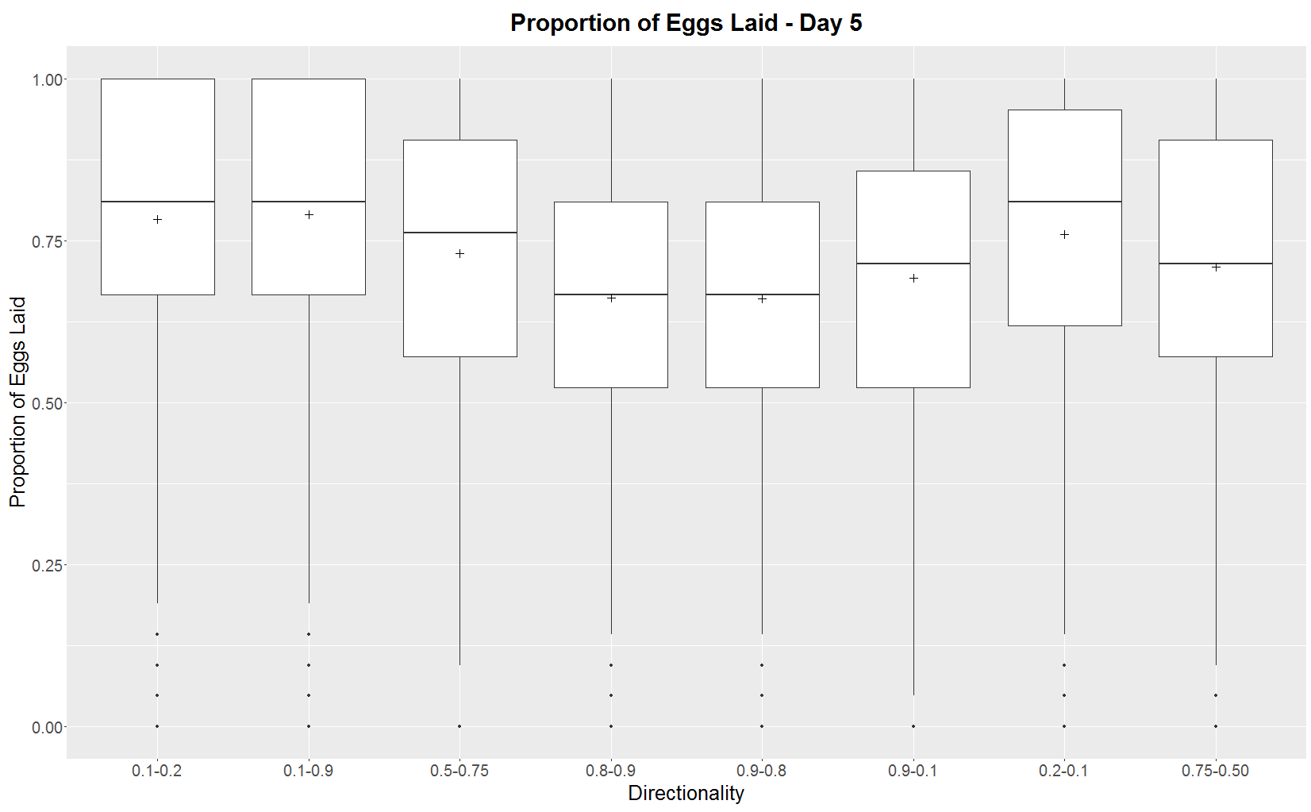

New sims that are correct, but with only 1,000 mons.

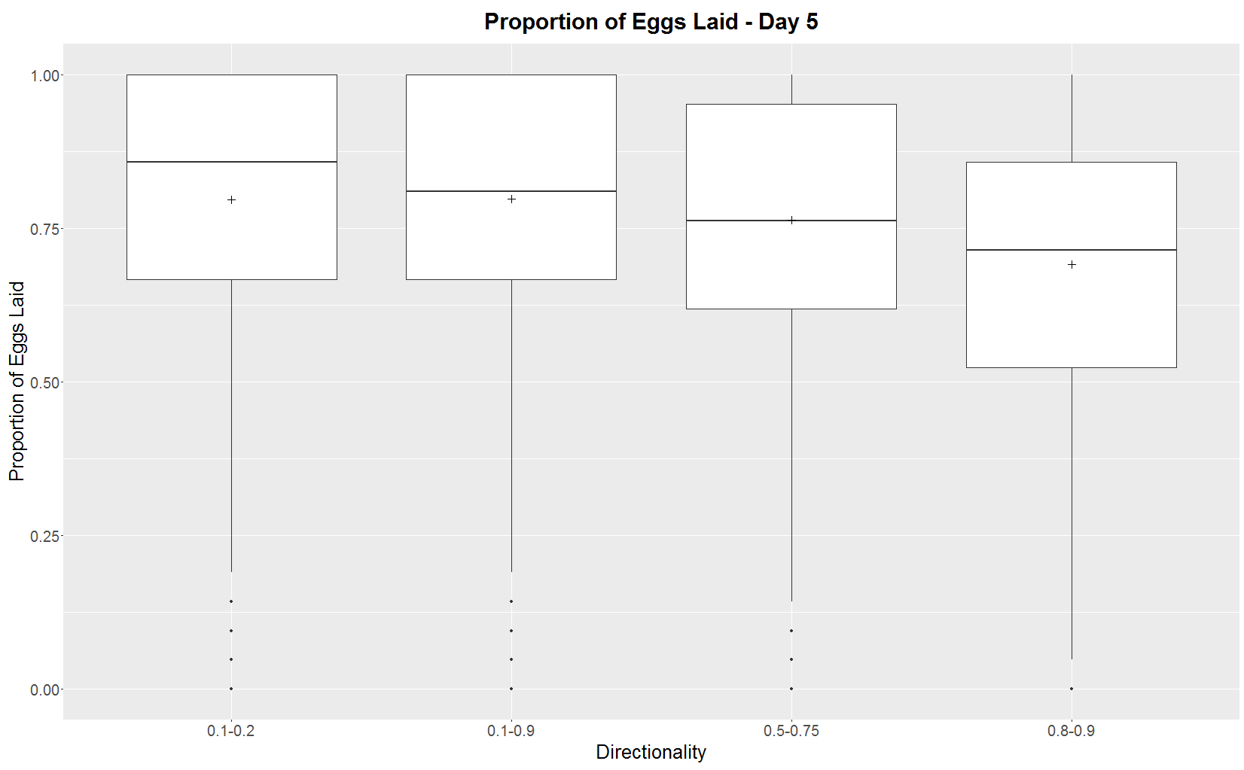

Original dir lsa.

Based on these, it looks like I didn’t run any of the lsa dir sims wrong, though impossible to tell with 0.8-0.9. They are far more similar to the right new sims than the wrong new sims.

So…tomorrow look at ms and LHS combos.

**May 17, 2016, Tuesday**

So manuscript for local sensitivity analysis for directionality is correct.

Now on to LHS combos. I’m going to run 1,000 monarchs with the opposite dirs to see how they compare. I’m not going to check 0.8-0.9 because they are so similar.

I was apparently in the middle of analyzing some sims, so I’ll just go one by one and make sure everything is right and done.

I guess mean prop eggs laid is best way to check if they are the same. I hadn’t calculated it for the LHS sims, but I guess I need to. Put in workspace Mon10 with other checkdir mean prop eggs laid.

LHS 2 is fine, I ran it right.

LHS 3 is probably fine, but since almost all eggs are laid, mean prop eggs laid is difficult to tell because almost all eggs laid.

LHS 10 appears to BE WRONG.

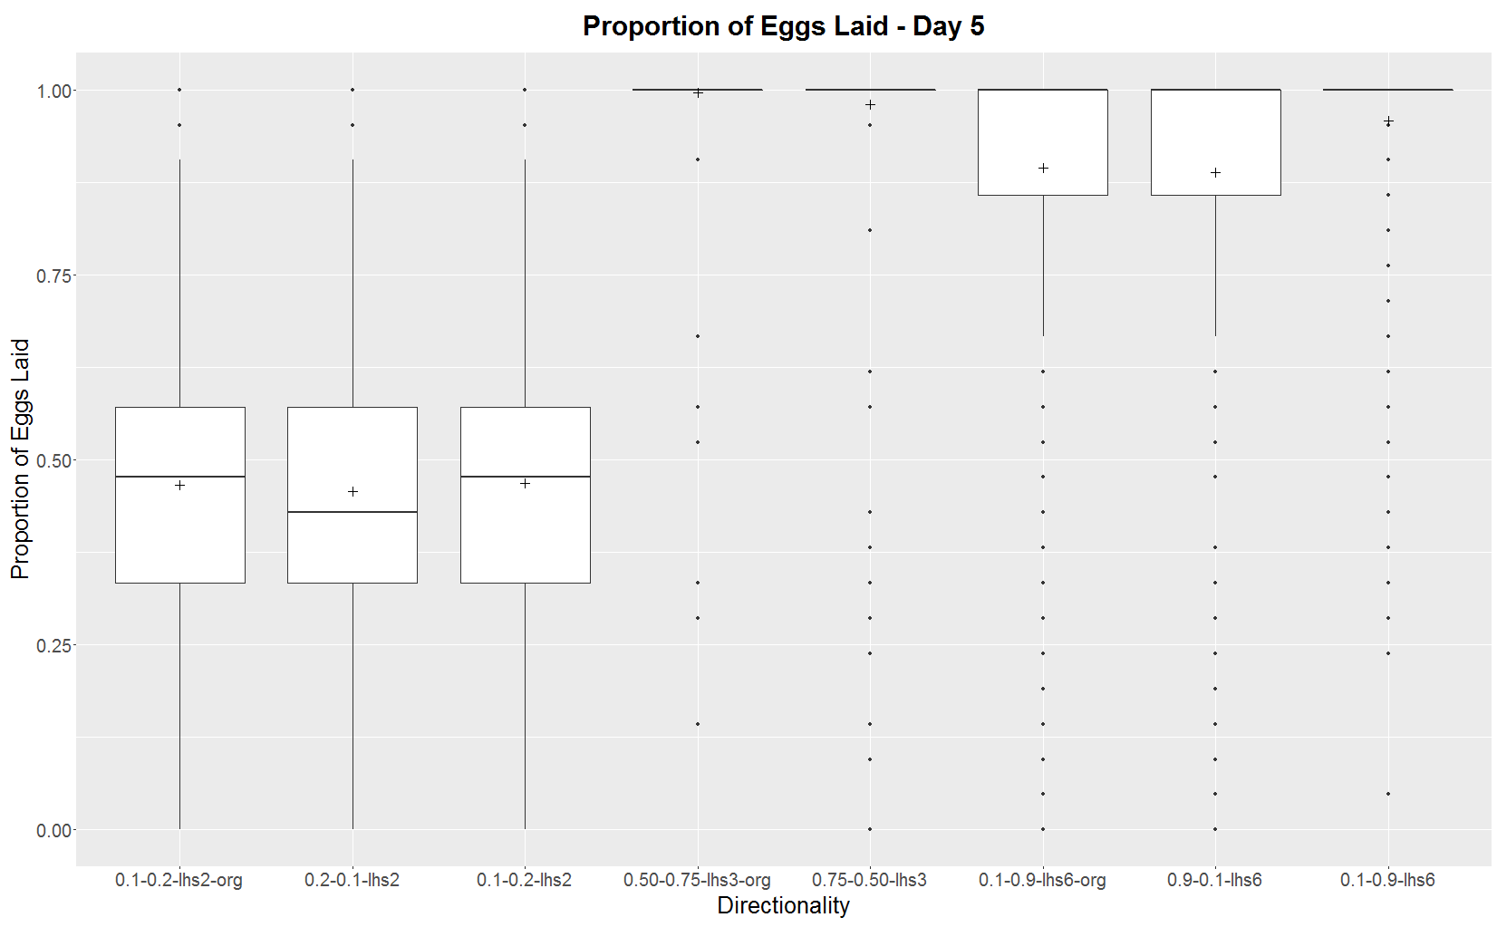

**June 2, 2016, Thursday**

Testing some shapefiles made by technicians in RS.

Shapefile is too big to run in RS GUI; get an out of memory error.

First run of Cory’s model on speedy2 returned error because ProbEggs in RS and probEggs in ArcMap.

Seems to have worked just fine now. CumEggsPerZone is 245 MB though. To really test it I should map the coordinates, maybe.

**June 28, 2016, Tuesday**

Getting coords for new tech shapefiles.

I was thinking in the future if I do an irregular area like the des moines lobe, I need to find another way to populate the shapefile with monarch agents, since I can’t use a square.

Probably have to do something where I try a bunch from a square around the shapefile and see which ones are in the shapefile.

Also remove some columns from attribute table to shrink .dbf.

**June 29, 2016, Wednesday**

Farm Progress Video:

|  |  |  |  |
| --- | --- | --- | --- |
| **CumEggs Filenames on 5/12** | **Cumulative Eggs** | **Monarch Agents (from Monarchs output file)** | **Ticks (from Monarchs output file)** |
| CumEggs.2016.May.12.14_33_47 | Empty | Empty |  |
| CumEggs.2016.May.12.14_28_39 | 788 | 3 | 10 |
| CumEggs.2016.May.12.13_53_32 | Empty | 25 | 9 |
| CumEggs.2016.May.12.13_38_35 | 520 | 3 | 10 |
| CumEggs.2016.May.12.13_34_41 | 506 | 3 | 10 |
| CumEggs.2016.May.12.13_29_27 | 214 | 1 | 10 |
| CumEggs.2016.May.12.11_46_12 | Empty | 1 | 1 |
| CumEggs.2016.May.12.11_44_09 | Empty | 3 | 4 |
| CumEggs.2016.May.12.09_24_46 | 164 | 1 | 10 |
| CumEggs.2016.May.12.08_45_57 | Empty | 1 | 4 |
| CumEggs.2016.May.12.08_43_42 | 70 | 1 | 10 |
| CumEggs.2016.May.12.08_41_15 | Empty | 3 | 6 |
|  |  |  |  |
|  |  |  |  |
|  |  |  |  |

Ugly color are test runs.

Turns out I recorded cumulative eggs from 25 agent runs in my GIS notes at the time: *Cumulative Eggs results: CumEggs.2016.May.11.11_18_05 was from an improved habitat run with 25 mons that ran until 10 ticks. Total eggs was 5700. CumEggs.2016.May.11.11_39_36 was from current habitat with 25 mons and 10 ticks. Total eggs was 4372 eggs. So improve habitat is 30% more eggs.*

The two that I used for 3 monarchs are almost certainly the 788 vs 520 eggs, so a 50% increase in eggs.

Notes on tech shapefile runs are in GIS Notes

**July 6, 2016, Wednesday**

Setting up government laptop to connect to campus wifi. For NetReg I said the laptop was personally owned.

**July 18, 2016, Monday**

How to export and import the Monarch model. When exporting, select all the files in the right column, like .classpath.

When importing, make a new empty RS project. For USGS computer I used the default workspace in C:\Users. I created a new Monarch RS project and imported the .zip into it. I had to move the data files, the src files, and the Monarch.rs folder to the correct folders or place, and the text files like .classpath, etc., to the root. Then it ran.

**Compile Results – Local Sensitivity Analysis**

***Step Length***

This first graph is for the baselines of the other parameters: remembered=10, perception=100, and directionality=0.5-0.75. Need to see if this same relationship holds for when other parameters vary…



After fixing model, the “60” here is really step=30 and remembered=10. Previous graph is all remembered=0.

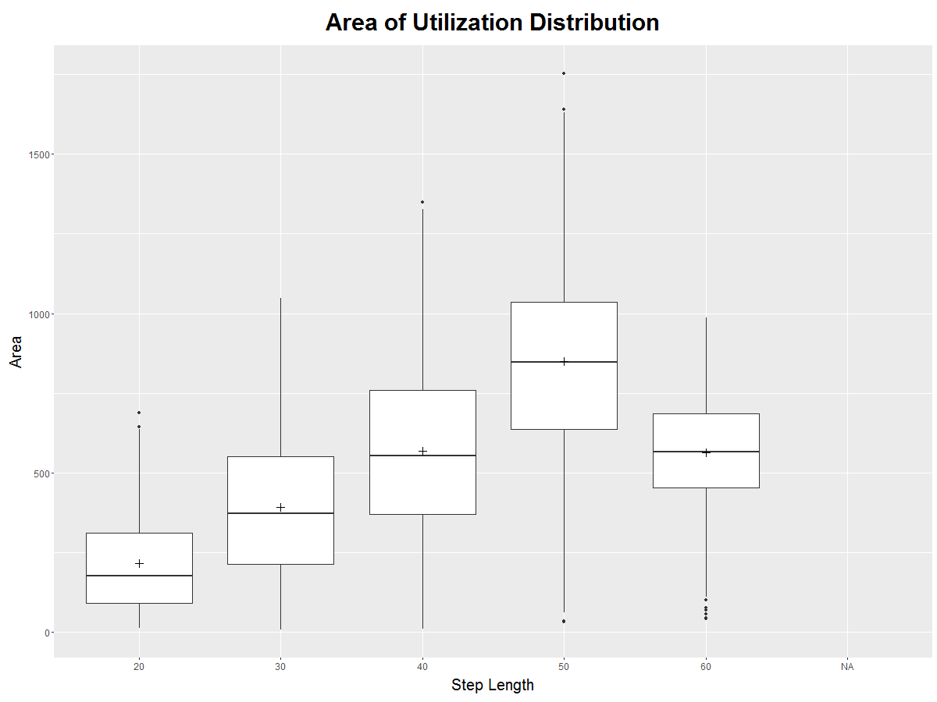

***Remembered***

For remembered at 30m step length (runs 38, 58, 60). Run 60 only has 500 UDs.

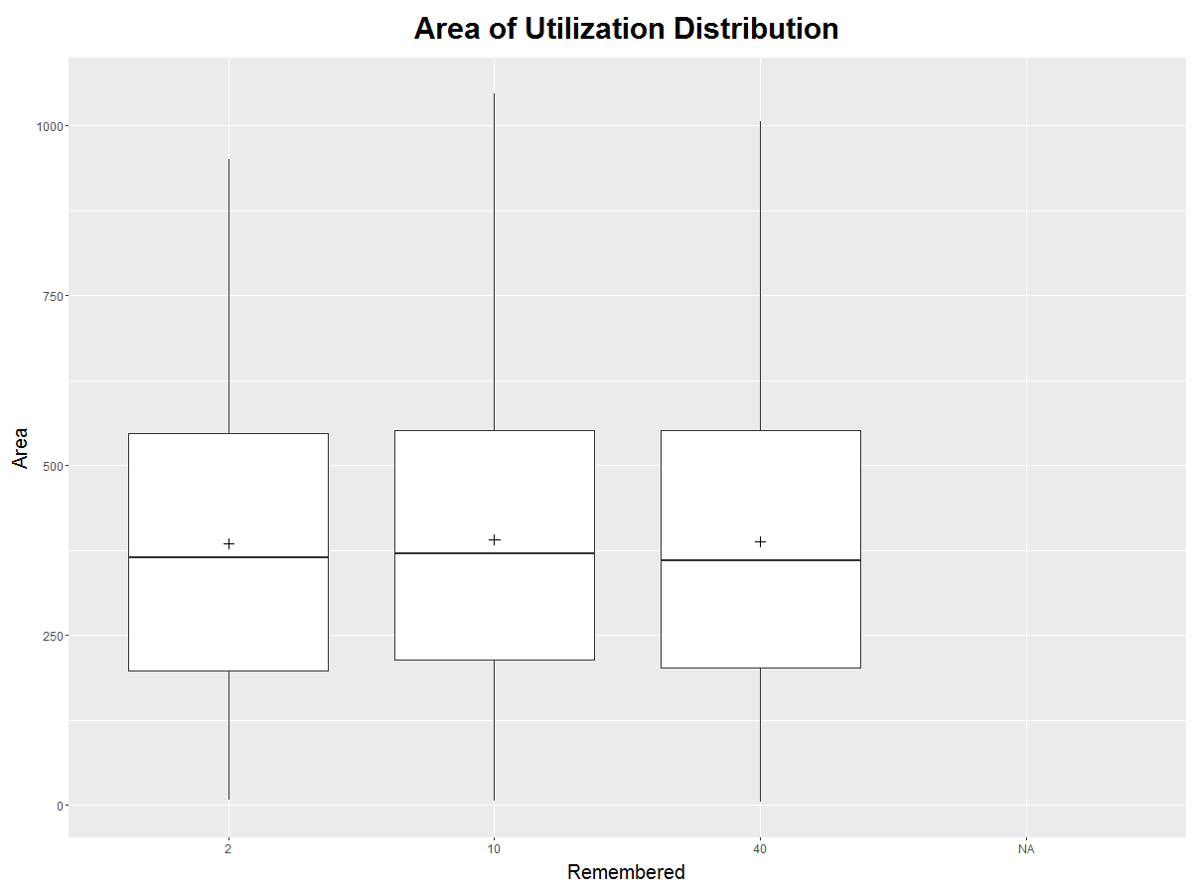

For remembered at 50m step length (runs 45, 70, 71).

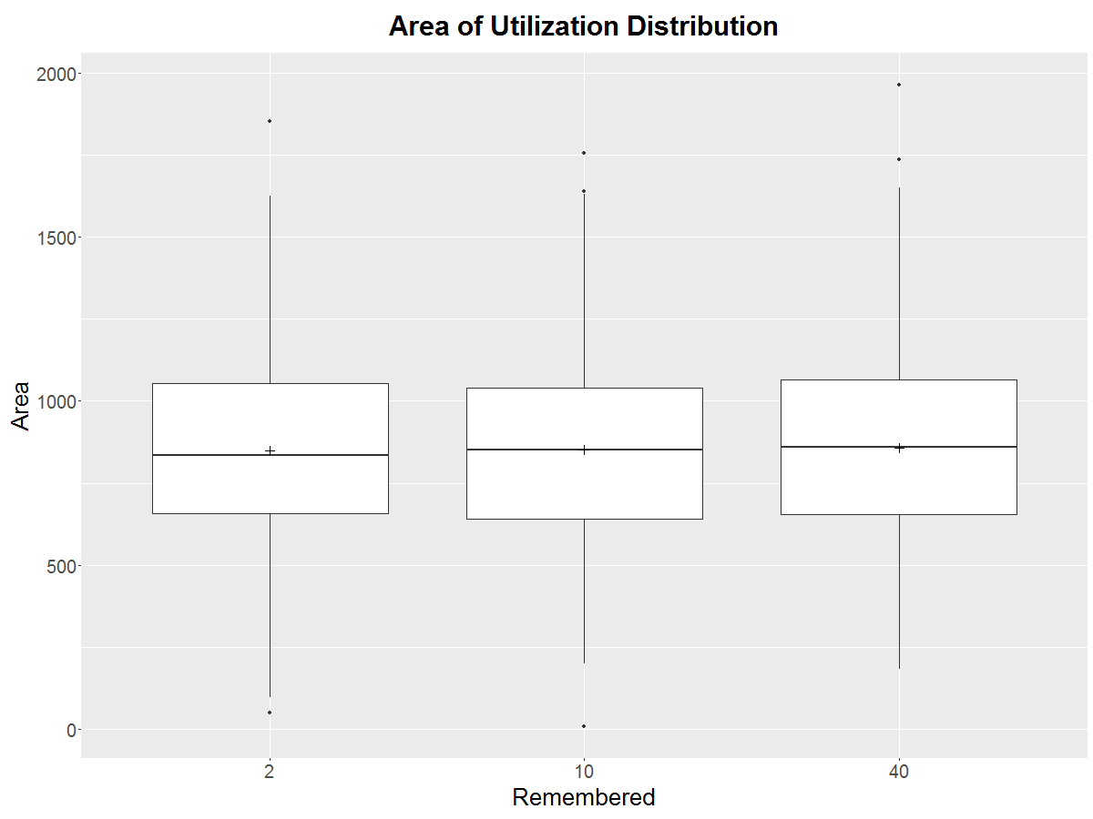

***Directionality***

Directionality for step=30, rem=10, and perc=100.

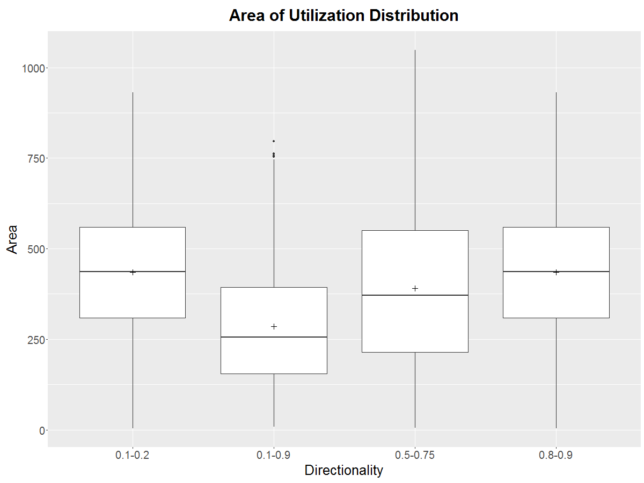

***Perception***

Perception by UD area for step length 10. Both of these distributions are skewed heavily toward 0. Both are really small relative to other parameterizations, as well.

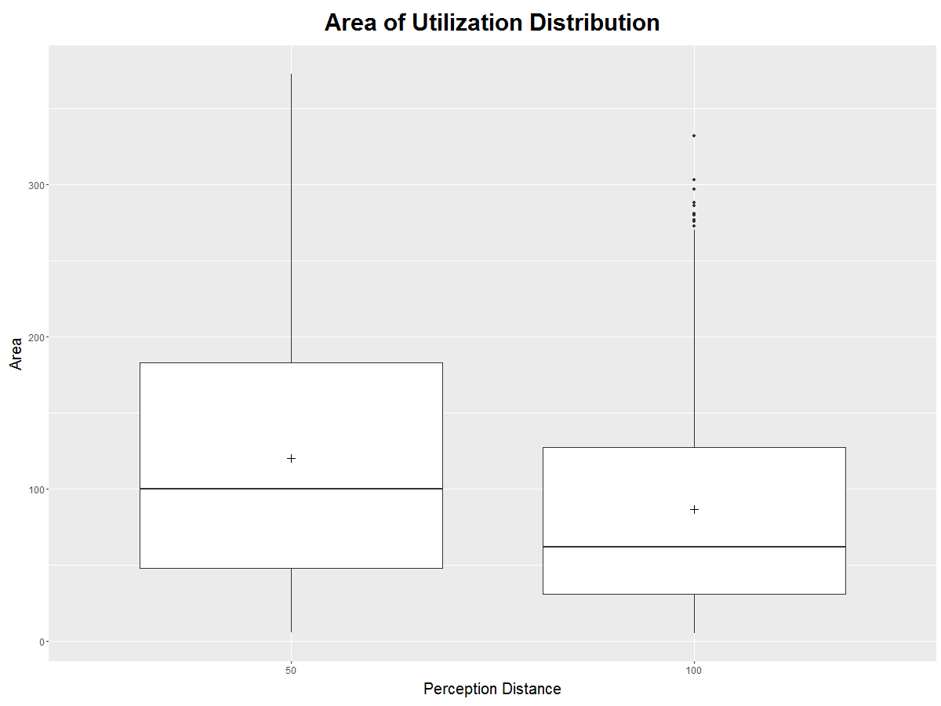

**Possible improvements:**

At times don’t make decisions on probEggs/MW density and just fly.

Levy flights instead of corr rand walk – would require variable step length.

Change corr rand walk angle to change if bounce into edge too often – change so that its different depending on probEggs – shouldn’t get stuck against probEggs = 0 edges.

Density dependence

ProbEggs also scaled by how many eggs remaining to lay or have laid

Wind – change perception distance to oval or ellipse and create bias in movement direction, changing strength according to wind speed.

Keep track how many different monarch agents laid eggs in a polygon

***Add bounces to cumulative steps and distance moved***

***Add ability to turn off network code which is usually only used in GUI and small simulations***

Narrow field of view

When randomly placing monarchs in the beginning, check if they fall in a polygon and if not, choose another spot. This way can be randomly placed throughout any shape of shapefile.

Fix code so if they jump twice in a row, they get moved back inside.

Make code easier to read by making more methods – in particular, fix when CRS is set so it’s not set every time.

**Larger simulations**

Teresa saw about 5 Monarchs per mile along the roads, which is about 10 per sq mile (males and females). So let’s say monarch females range in density somewhere between 5-20 per sq mile. St Co is 574 sq miles, so need 2,870 – 11,480 monarchs.

This run may not require too much processing time, but in the future we plan to run a much larger area with many more Monarchs. Currently the landscape is ~8 sq miles with 724 polygons. We would like to run all of story county, which would be 37,148 polygons, 574 sq miles, 148,465 ha, and 3,000-10,000 Monarchs.

First TestShapefile is 2510.2 ha = 9.65 sq miles. 724 polygons.

Second TestShapefile is 7728 ha = 29.8 sq miles. 1480 polygons.

Output from GUI defaults to C:\Users\tgrant\Documents\Repast\Monarchs

Output from batch runner goes to C:\Users\tgrant\Documents\Repast\Monarchs\output

Simulation results are in C:\Users\tgrant\Documents\Repast\Monarchs\output

**Bounding Coordinates for different shapefiles (I need new code to populate irregular shaped shapefiles):**

There a few places in the code where lat lon coords have to be changed: the static xmin, xmax, ymin, and ymax in Monarch.java, the init coords for visualizing the network, and initializing the locations of the monarchs.

When switching between shapefiles, also remember to change code to reference correct shapefile. Also change range of probEggs in corrrandwalk2. Also change bouncecounter random loc (line 422).

Need to change shapefile name, init coords, agent coords, static x and y’s, bounce coords…bounding coords should be very slightly outside to allow bounce. Static x and y’s should be slightly outside to allow bounce, but random loc of initial monarchs should be slightly inside so they don’t start outside.

***Brookes_Counties_1_Final.shp***

Mid lat/long for network initialization: -93.0, 41.7

*Corners, slightly outside (measured in ArcMap):*

SW corner: 41.15, -93.82

SE corner: 41.15, -92.29

NE corner: 42.3, -92.29

NW corner: 42.3, -93.82

*Corners, slightly inside, measured in ArcMap:*

SW corner: 41.17, -93.69

SE corner: 41.17, -92.415

NE corner: 42.205, -92.415

NW corner: 42.205, -93.69

***Alec_Counties_1_Final.shp***

Mid lat/long for network initialization: -93.3, 42.9

*Corners, slightly outside (measured in ArcMap):*

SW corner: 42.2, -93.98

SE corner: 42.2, -92.53

NE corner: 43.505, -92.53

NW corner: 43.505, -93.98

*Corners, slightly inside, measured in ArcMap:*

SW corner: 42.3, -93.92

SE corner: 42.3, -92.78

NE corner: 43.495, -92.78

NW corner: 43.495, -93.92

***Juliasffinalmap.shp***

Mid lat/long for network initialization: -94.5, 41.7

*Corners, slightly outside (measured in ArcMap):*

SW corner: 41.15, -95.165

SE corner: 41.15, -93.69

NE corner: 42.22, -93.69

NW corner: 42.22, -95.165

*Corners, slightly inside, measured in ArcMap:*

SW corner: 41.17, -95.03

SE corner: 41.17, -93.82

NE corner: 42.2, -93.82

NW corner: 42.2, -95.03

***Jackie_FINAL2.shp***

Mid lat/long for network initialization: -94.3, 40.85

*Corners, slightly outside (measured in ArcMap):*

SW corner: 40.57, -94.93

SE corner: 40.575, -93.55

NE corner: 41.165, -93.55

NW corner: 41.16, -94.93

*Corners, slightly inside, measured in ArcMap:*

SW corner: 40.58, -94.91

SE corner: 40.58, -93.56

NE corner: 41.16, -93.56

NW corner: 41.155, -94.92

***Cory1_FINAL2.shp***

Mid lat/long for network initialization: -94.7, 42.9

*Corners, slightly outside (measured in ArcMap):*

SW corner: 42.19, -95.4

SE corner: 42.2, -93.92

NE corner: 43.505, -93.97

NW corner: 43.505, -95.4

*Corners, slightly inside, measured in ArcMap:*

SW corner: 42.215, -95.3

SE corner: 42.22, -93.98

NE corner: 43.495, -93.973

NW corner: 43.495, -95.38

***Farm Progress Show Boundaries***

Mid lat/long for network initialization: -93.8, 42.04

Corners, slightly outside (measured in ArcMap):

SW corner: 42.0215, -93.838

SE corner: 42.021, -93.7745

NE corner: 42.058, -93.774

NW corner: 42.0585, -93.8375

Corners, slightly inside, measured in RS:

SW corner: 42.024, -93.836

SE corner: 42.0215, -93.7755

NE corner: 42.0573, -93.775

NW corner: 42.0575, -93.8365

***Story County Lat Long Boundaries (measured within RS):***

SW corner: 41.8633, -93.6981

SE corner: 41.8627, -93.2318

NE corner: 42.2092, -93.2318

NW corner: 42.2096, -93.6987

Slightly inside:

SW corner: 41.8634, -93.6980

SE corner: 41.8628, -93.2319

NE corner: 42.2091, -93.2319

NW corner: 42.2095, -93.6986

Slightly outside to allow bounce – about 100-200m or so outside:

SW corner: 41.8625, -93.6995

SE corner: 41.8605, -93.2305

NE corner: 42.2100, -93.2300

NW corner: 42.2107, -93.7005

**NW Iowa**

Slightly inside:

SW corner: 41.8634, -93.6980

SE corner: 41.8628, -93.2319

NE corner: 42.2091, -93.2319

NW corner: 42.2095, -93.6986

**NW Iowa clip**

Slightly inside (measured in ArcMap with dataframe in UTM projection, shapefile wouldn’t load in RS GUI – out of memory error):

SW corner: 41.874, -96.087

SE corner: 41.916, -93.732

NE corner: 43.483, -93.754

NW corner: 43.440, -96.169

**West Lyon County**

A rectangle completely enclosed by the shapefile – for randomly placing monarch agents

SW corner: 43.26, -96.52

SE corner: 43.26, -96.44

NE corner: 43.5, -96.44

NW corner: 43.5, -96.52

Initialization coords: -96.5, 43.4

A rectangle enclosing shapefile – at least 50 m outside – for static x’s and y’s

SW corner: 43.257, -96.605

SE corner: 43.257, -96.424

NE corner: 43.502, -96.424

NW corner: 43.502, -96.605

**R Workspaces**

Mon1 – original, some graphs, UDs for run 33

Mon2 – UDs for run 38,45,46,47, and **86**. Pub graphs for **step length** UDS, pub graphs for egg density by **step length**, boxplots for individual habitat type egg density by **step length**

Mon3 – UDs for run 56

Mon4 – UDs for run 52, 75 – 10m step by perception

Mon5 – UDs for run 58, 60, graphs for **remembered** UDs, bbmm testing, **remembered** egg density graphs

Mon6 – UDs from run 65, 61, 64 graphs for **perception** UDs, **perception** egg density graphs

Mon7 – UDs from run 70, 45, 71 – note that dbbmms45 here is from speedy2, I accidentally overwrote it. I had already calculated the area45 and area_s45 though, so those are from my PC.

Mon8 – UD for run 45 from speedy2

Mon9 – UD graphs for runs 80, 81, 84, 38, which is **directionality**. Also egg density graphs for **directionality**.

Mon10 – egg density for run92, 76-78, 104-105, UD for 95, MEAN PROPORTION OF EGGS LAID graphs, lhs8 egg density, checkdir for lsa and lhs combos.

Mon11 – UDs for runs 89, 91, 93 – only i=149-1000, also UDs for run99, run97

**Linux Commands**

find – look at all the files

find –name “*Mar.03*”

module load R

ll – files, tab complete

cd .. – up one dir, cd R

run cmd.exe in windows to use pscp.exe

top, q

source(“speedy2UDscript.R”)

Ctrl C to stop R running

“C:\Program Files (x86)\PuTTY\pscp.exe” C:\Users\tgrant\Downloads\file tgrant@speedy2:/home/tgrant/R/.

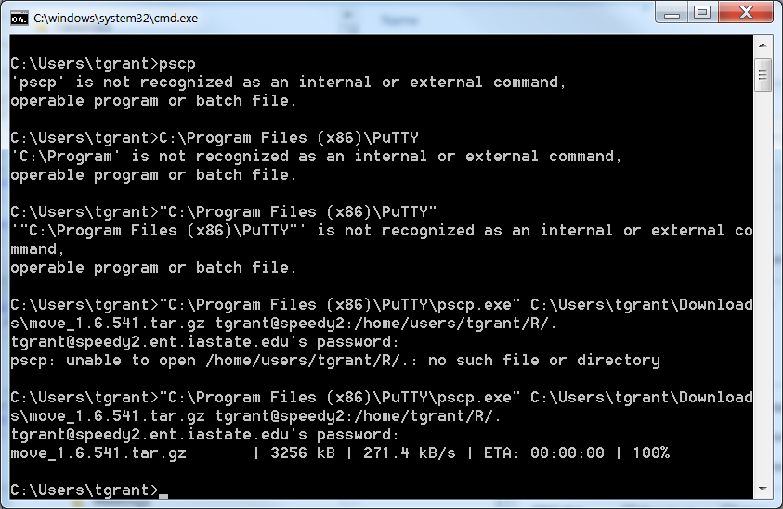

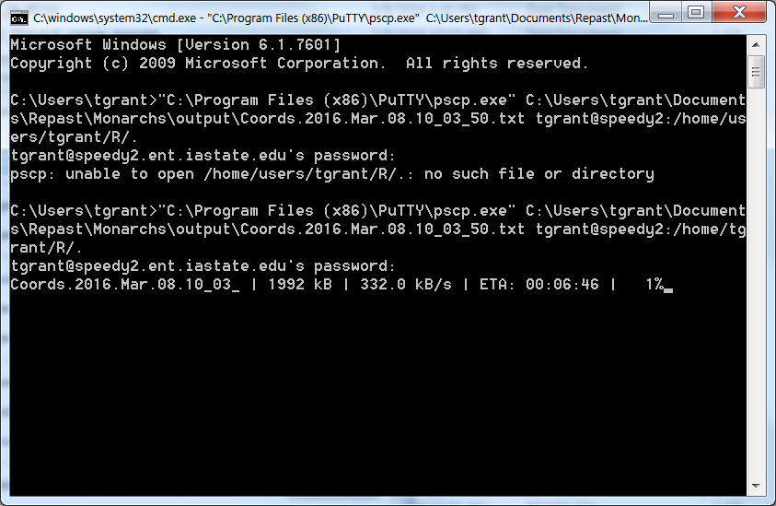

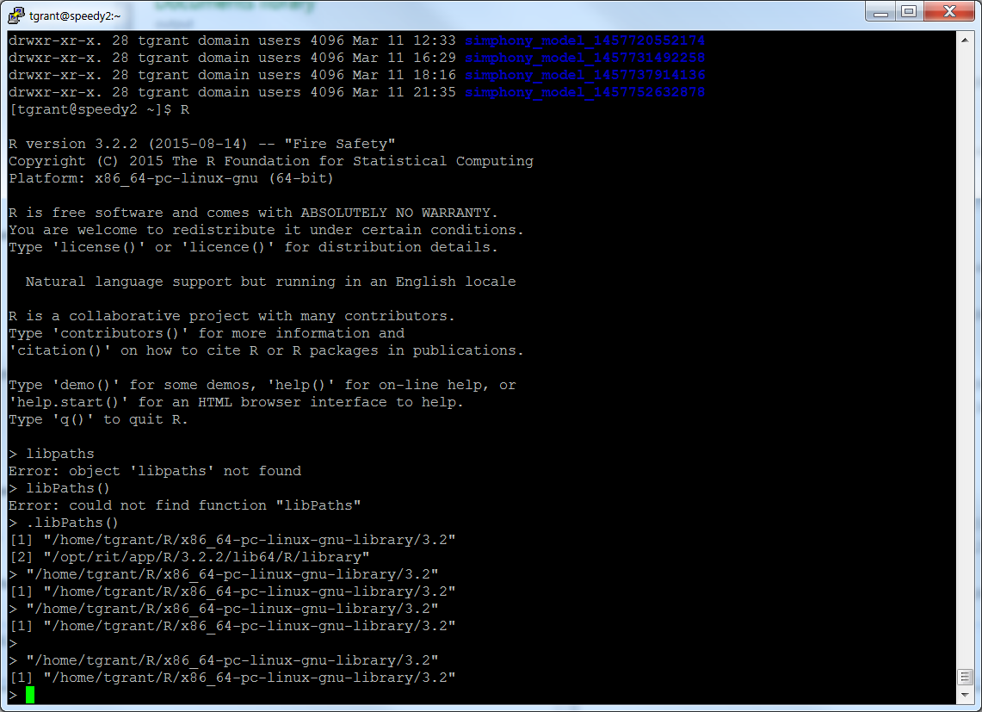

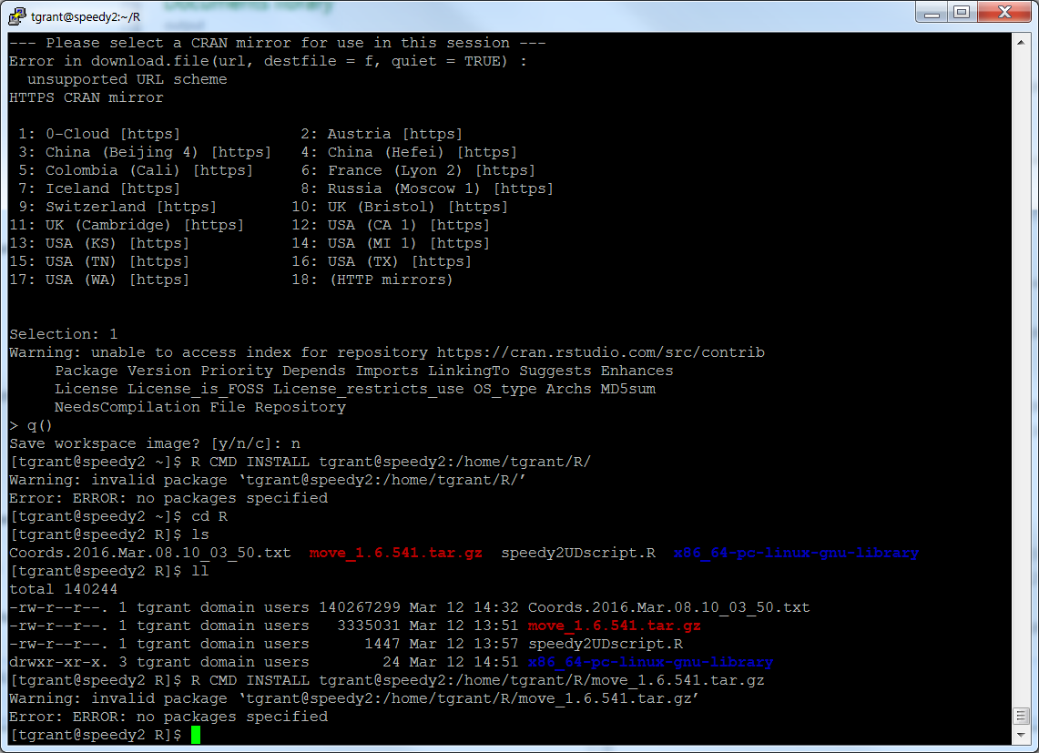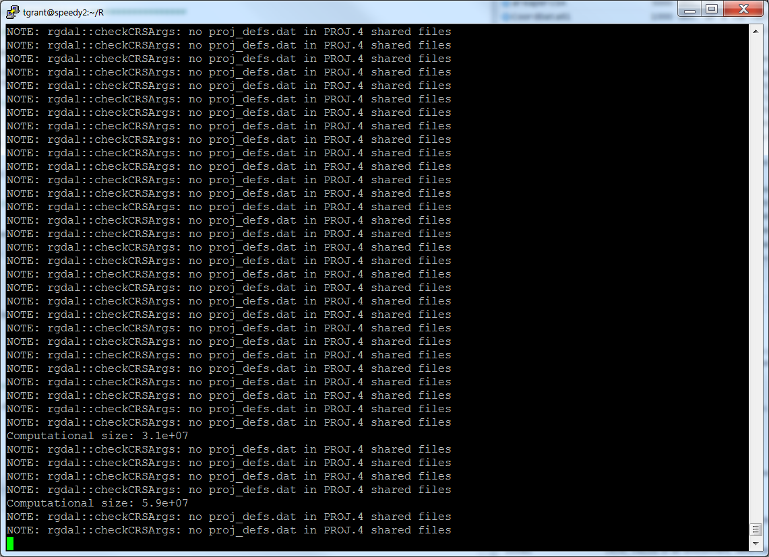

**Introduction**

In constructing this model, we operate under 2 important hypotheses: 1) Monarchs are not laying all the eggs that they are capable of laying due to habitat constraints; and 2) Monarchs are move large distances across the landscape and are adept at finding habitat patches, i.e., they don’t get “stuck” in any habitat patch and never stay in one place for too long.

**Methods Section**

*Model Description*

For each Monarch Agent on each step:

1. Query/Identify all Zone Agents within perception distance of the Monarch Agent
2. Retrieve probEggs (the unadjusted probability of laying eggs in a Zone Agent) for each Zone Agent within perception distance
3. Calculate distance between Monarch Agent and nearest point of each Zone Agent
   1. If distance = 0 (i.e., the Monarch is currently within that Zone Agent), the Monarch Agent has a chance to lay eggs
4. Calculate area of Zone Agents that overlaps with the perception distance around the Monarch Agent and adjust probEggs accordingly
5. Check Zone Agents to see if they are in list of remembered polygons and adjust probEggs accordingly
6. Choose a polygon to move toward according to the adjusted probEggs of the Zone Agents within perception distance
   1. If there is only 1 Zone Agent within perception distance (the Zone Agent currently occupied), move in a correlated random walk
   2. If current Zone Agent is chosen, move in a correlated random walk
7. Calculate heading toward nearest point of chosen polygon and move in that direction the distance of the step length
8. Return to Step 1 until maximum movement distance is reached

*Sensitivity Analysis*

Using expert opinion, initial probability of laying eggs (probEggs) was determined for each habitat type. However, these probabilities were substantially over-estimated as simulated Monarchs always laid all their eggs. Because Monarchs are decreasing, we assume that Monarchs are not laying all their eggs and, even if they are, constructing a model where they don’t lay all their eggs will provide more insight. We adjusted probEggs lower until Monarchs laid ~40% of their eggs daily and parameterized the model so that they lay 2 eggs per step. We parameterized the baseline model according to elicitation from experts on likely parameter values (Table 1). We then tested the sensitivity of the mean proportion of eggs laid daily and mean proportion of eggs laid in each zone to several parameters (Table 1). Each parameter combination scenario was run with 1000 Monarchs. The landscape used was an agricultural landscape in Story County, Iowa, USA, and results are to some degree conditional on the landscape used, however, the landscape is very similar to much of the landscape in Iowa, with a lattice of dirt roads and a matrix of agricultural fields.

|  |  |  |
| --- | --- | --- |
| **Parameter** | **Baseline Value** | **Values Tested** |
| Step Length | 50 | 10, 25, 75, 100 |
| Directionality | 0.75 | 0.1, 0.25, 0.5, 0.9 |
| Perception Distance | 100 | 25, 50, 200, 400 |
| Step Polygons Remembered | 10 | 1, 2, 5, 20, 40 |

Table 1.

Table 2. ProbEggs per polygon/habitat type.

Monarch experts all agree that Monarchs cover large distances each day and rarely stay in one place for long, though they may return after a time. Thus utilization distributions of Monarchs should be large and eggs laid should be spread over many polygons, as opposed to small utilization distributions with eggs tending to accumulate in fewer polygons. Therefore, we also tested the sensitivity of distribution of eggs on the landscape to the different parameters. The proportion of eggs in each individual polygon was scaled by multiplying by 100,000 to make the numbers easier to interpret.

**Results**

*Sensitivity Analysis*

Mean Eggs Laid per Day

As step length becomes shorter, Monarchs have more opportunities to lay eggs, resulting in more eggs laid per day (Figure 1). Consequently, step length must be balanced appropriately with probEggs to achieve realistic egg laying rates.

As directionality becomes smaller, Monarchs travel in more curvy paths. Consequently, with low directionality, they are less likely to find their way out of a good habitat patch, and therefore lay slighting more eggs overall. However, the difference is relatively minor and the SDs overlap a good deal (Figure 2).

Increasing perception distance does not increase the proportion of eggs laid because the Monarchs make decisions at each step which direction to move. Consequently information from too far beyond the step length provides little improvement to their search behavior. Perception distances at or below the step length are of little or no value to the Monarch and their ability to find good habitat suffers (Figure 3).

Increasing the number of remembered polygons decreases proportion of eggs laid slightly, as Monarchs are forced to leave good habitat and may or may not find more suitable habitat (Figure 4).

Figure 1. Mean proportion of eggs laid each tick for five simulated scenarios with varying step lengths and N=1000.

Figure 2. Mean proportion of eggs laid each tick for five simulated scenarios with varying directionality and N=1000.

Figure 3. Mean proportion of eggs laid each tick for five simulated scenarios with varying perception distance and N=1000.

Figure 4. Mean proportion of eggs laid each tick for five simulated scenarios with varying number of step polygons remembered and N=1000.

eggs laid per zone

Larger mean proportions and especially larger standard deviations indicate that eggs have a more clumped distribution on the landscape and likely indicate that Monarch agents are utilizing relatively small areas, contrary to our hypothesis that they are good at utilizing the entire landscape and finding good habitat. I use the highest density right-of-way habitat (MWROW60-100) and non-GMO corn habitat as the primary metrics. MWROW60-100 are small polygons and there are a large number of polygons (189) and they have a high probEggs (0.09), so if Monarch agents were getting stuck in high quality habitat there would be higher SD of the mean proportion of eggs laid in each of these polygons. Non-GMO corn polygons have a high probEggs (0.085) but are much larger than ROW polygons and can exhibit different results.

Step Length

Step length had a relatively minor effect on the distribution eggs, except for the smallest step length in small polygons. At 10 m, the SD is high, indicating clumped distribution of eggs relative to other step lengths.

What is happening with 18 m????? Check analysis.

Directionality

Directionality had opposite effects for large and small polygons. When directionality was high, small polygons had more eggs, perhaps indicating the ability to find more of the polygons or perhaps because they spent less time in the large polygons.

Higher directionality decreased the number of eggs in large polygons, because Monarch agents were more likely to run into the edge and have a chance of leaving. Low directionality would make the Monarch agents more likely to circle within large polygons.

Perception Distance

Larger perception distance increased clumping, I can’t quite figure out why. Perception distances of 25-50 m are shorter than or equal to the step length and the result is similar to a correlated random walk.

Histograms for perception distance of 400 and perception distance of 100 corroborate that eggs are more evenly spread when perception distance is 100, though large outliers with many eggs may be the main culprit.

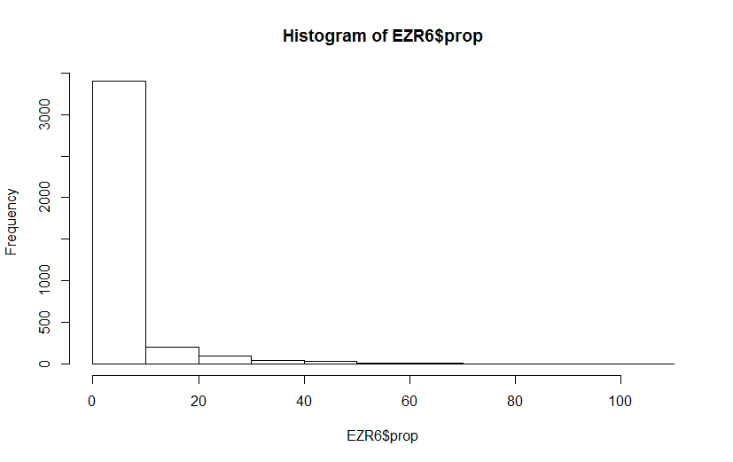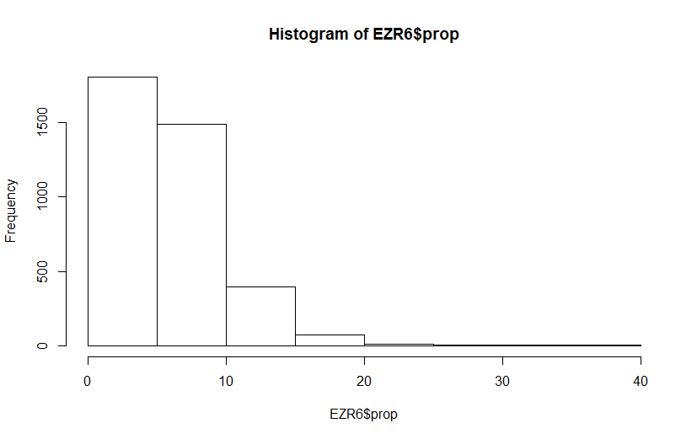

Figure. Scaled proportion of eggs per zone for perception distance 400 (left) and 100 (right). Note scale – larger SD may be primarily the result of a few polygons with many, many eggs.

The effect of perception distance on large polygons was relatively minor except for perception distance of 25. Perhaps it was less likely to see habitat outside its current polygon and be able to leave.

Obviously, a perception distance less than or equal to the step length makes no sense and would not be used in final analyses.

Remembered

Remembering fewer sites has opposite effects on large and small polygons. For small polygons, remembering fewer polygons results in a more clumped distribution of eggs. Remembering 20-40 polygons doesn’t seem improve distribution over remembering 10 polygons.

Large polygons like those with non-GMO corn are not affected by memory, therefore the change in number of eggs is likely due to the events in other polygons. For small remembered polygons, eggs in non-GMO corn is smaller, likely because Monarch agents are clumping more in ROW polygons.

**Synthesis**

The results indicate that the baseline model results in well-distributed eggs and habitat use, as it was designed to do. If future data indicates that egg distribution is more clumped than generally thought, we have the insight to start parameterizing the model in that fashion.